**INTRODUCTION TO DATA MANAGEMENT PROJECT REPORT**

(Project Semester August-December 2021)

***INDIA DISTRICT CENSUS 2011***

Submitted by

Shivam Tiwari

Registration No- 11915342

Programme – Bachelor of Technology

Section – KM009

Course Code - INT 217

Under the Guidance of

**Sandeep Kaur:23614**

**Assistant Professor**

**Discipline of CSE/IT**

**Lovely School of Computer Science and Engineering**

**Lovely Professional University, Phagwara**



**CERTIFICATE**

This is to certify that Shivam Tiwari bearing Registration no. 11915342 has completed INT 217 project titled, **“**INDIAN DISTRICT CENSUS 2011**”** under my guidance and supervision. To the best of my knowledge, the present work is the result of his/her original development, effort and study.

**Sandeep Kaur: 23614**

**Assistant Professor**

**School of Computer Science and Engineering**

Lovely Professional University

Phagwara, Punjab.

Date: 18/12/2021

**DECLARATION**

I, Shivam Tiwari student of 11915342 (B. Tech CSE) under CSE/IT Discipline at, Lovely Professional University, Punjab, hereby declare that all the information furnished in this project report is based on my own intensive work and is genuine.

Date: 17/12/2021 

Registration No.- 11915342 Shivam Tiwari

**Acknowledgement**

I, Shivam Tiwari, Registration Number- 11915342, a third year B.Tech CSE student of Lovely Professional University presents my this project report on the topic “**INDIAN DISTRICT CENSUS 2011**” under the guidance of **Sandeep Kaur** who is also our teacher in this course.

I want to thank my university for giving me the golden opportunity to be a part of this beautiful, contented and inspiring journey.

**Shivam Tiwari**



**Contents**

|  |  |  |
| --- | --- | --- |
| **Sr. No** | **Title** | **Page No** |
| 1 | Introduction | 6 |
| 2 | Objectives and Scopes | 7 |
| 3 | Source of Dataset | 8 |
| 4 | ETL Processes | 10 |
| 5 | List of Analysis with Results | 22 |
| 6 | Bibliography | 41 |

**Introduction**

**Data management** is the practice of collecting, keeping, and using data securely, efficiently, and cost-effectively. The goal of data management is to help people, organizations, and connected things optimize the use of data within the bounds of policy and regulation so that they can make decisions and take actions that maximize the benefit to the organization. A robust [data management strategy](https://www.oracle.com/in/database/) is becoming more important than ever as organizations increasingly rely on intangible assets to create value.

Managing digital data in an organization involves a broad range of tasks, policies, procedures, and practices. The work of data management has a wide scope, covering factors such as how to:

* Create, access, and update data across a diverse data tier
* Store data across multiple clouds and on premises
* Provide high availability and disaster recovery
* Use data in a growing variety of apps, analytics, and algorithms
* Ensure data privacy and security
* Archive and destroy data in accordance with retention schedules and compliance requirements

A formal data management strategy addresses the activity of users and administrators, the capabilities of data management technologies, the demands of regulatory requirements, and the needs of the organization to obtain value from its data.

**Objectives and Scopes**

After performing analysis of the mentioned dataset, the following outcomes (objectives) have been observed:

* District-wise population in different states.
* Male and Female population in different districts of a state.
* Number of literate people in districts of different states.
* Different age group people in different states.
* Number of different religious sec

**Source of Dataset**

**Source of Dataset:** kaggle.com/danofer/india-census?select=india-districts-census-2011.csv

The given Dataset consists of the variety of data including:

* District wise population
* Gender-wise population data
* Different religions count in a district
* Literacy Data
* Gender wise literacy
* Age group data
* Urban-Rural population
* SC/ST Population

The Dataset concludes the variety of data as mentioned above. Sample of the dataset is shown below:

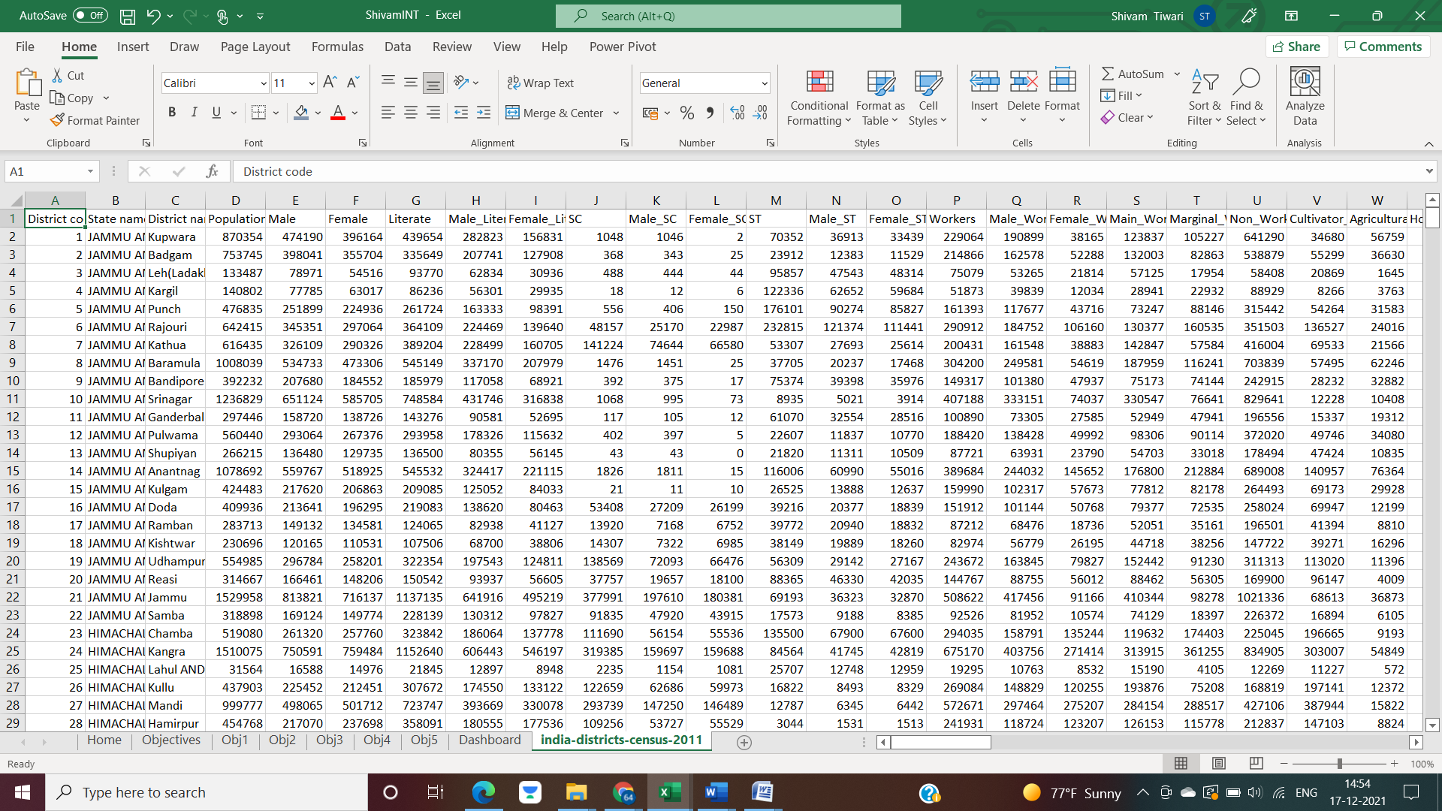

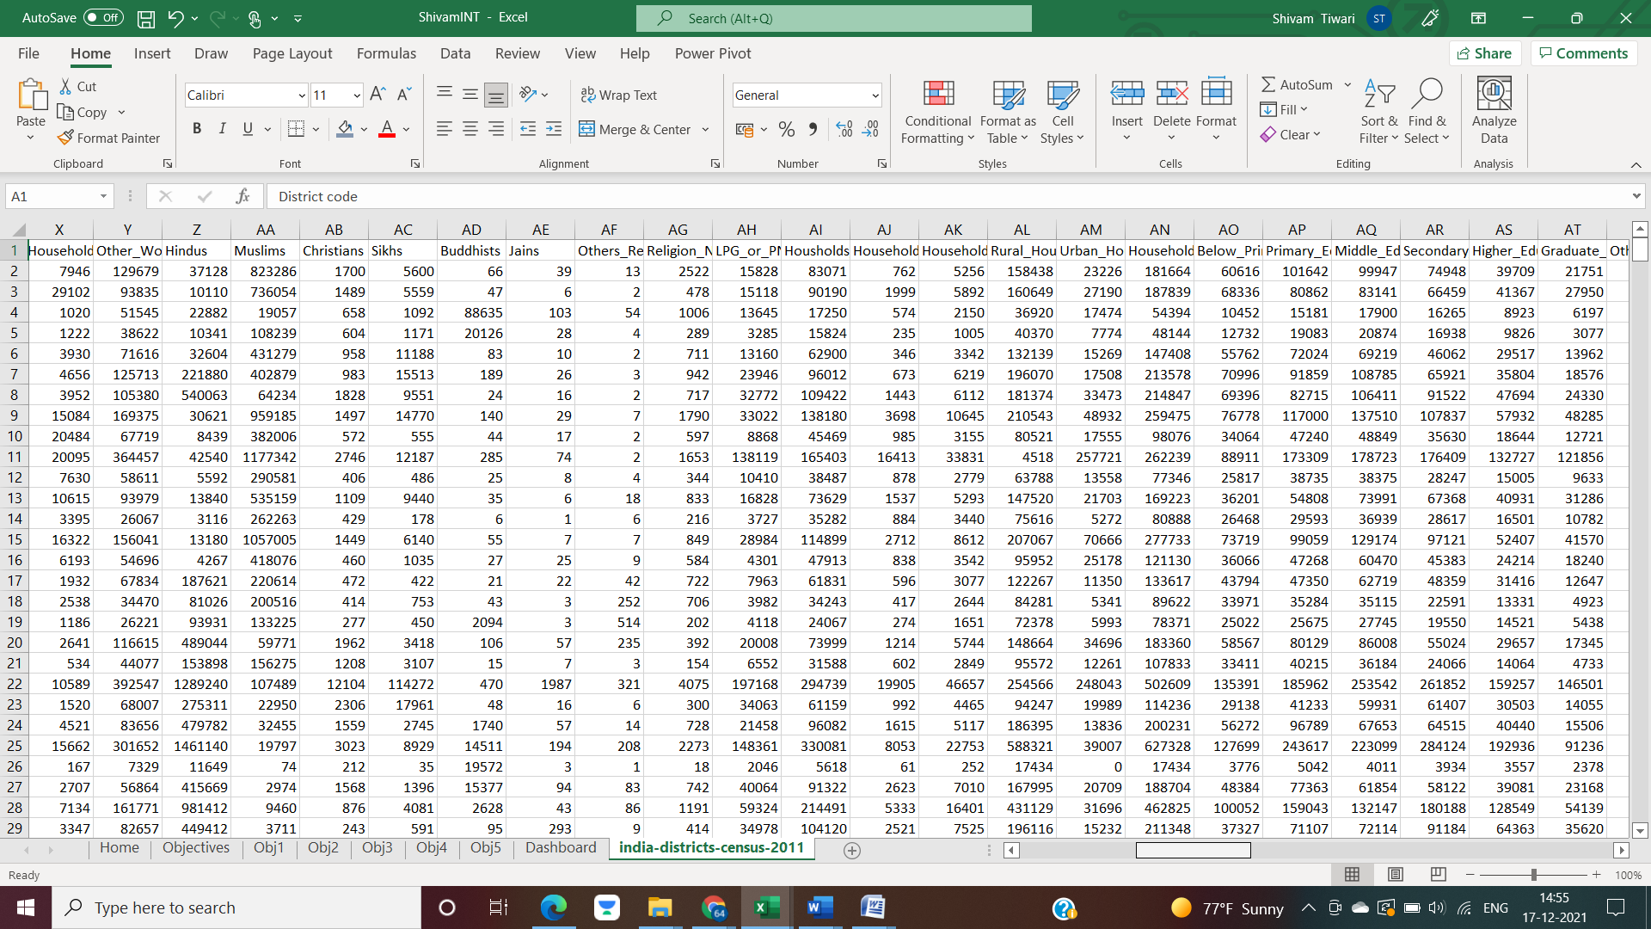

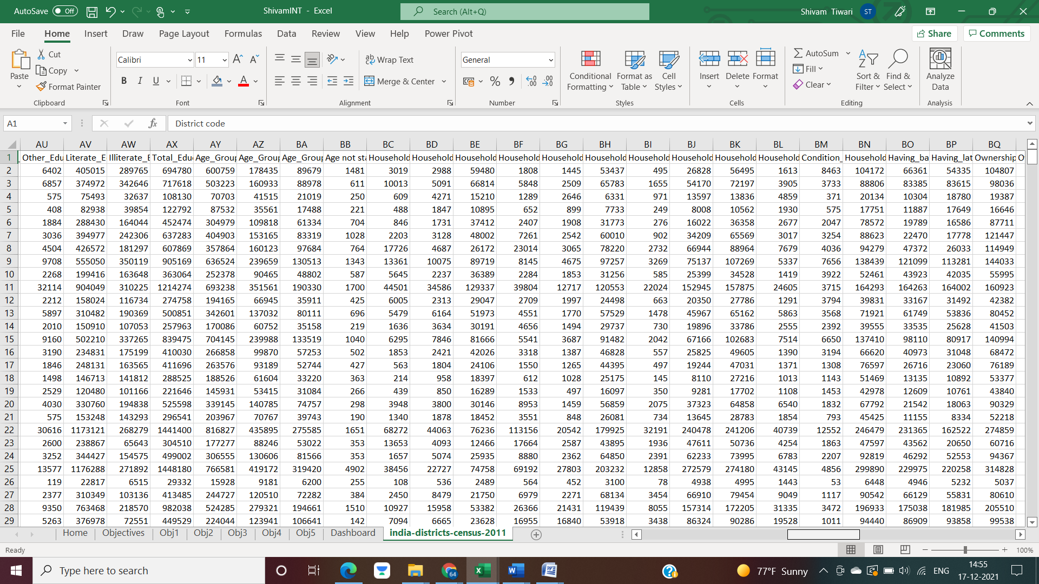

**ETL Process**

**ETL** is a process that extracts the data from different source systems, then transforms the data (like applying calculations, concatenations, etc.) and finally loads the data into the Data Warehouse system. Full form of ETL is Extract, Transform and Load.

It’s tempting to think a creating a Data warehouse is simply extracting data from multiple sources and loading into database of a Data warehouse. This is far from the truth and requires a complex ETL process. The ETL process requires active inputs from various stakeholders including developers, analysts, testers, top executives and is technically challenging.

In order to maintain its value as a tool for decision-makers, Data warehouse system needs to change with business changes. ETL is a recurring activity (daily, weekly, monthly) of a Data warehouse system and needs to be agile, automated, and well documented.

The ETL process of the Dataset is shown as below:

* Go to data and choose the CSV file as new query

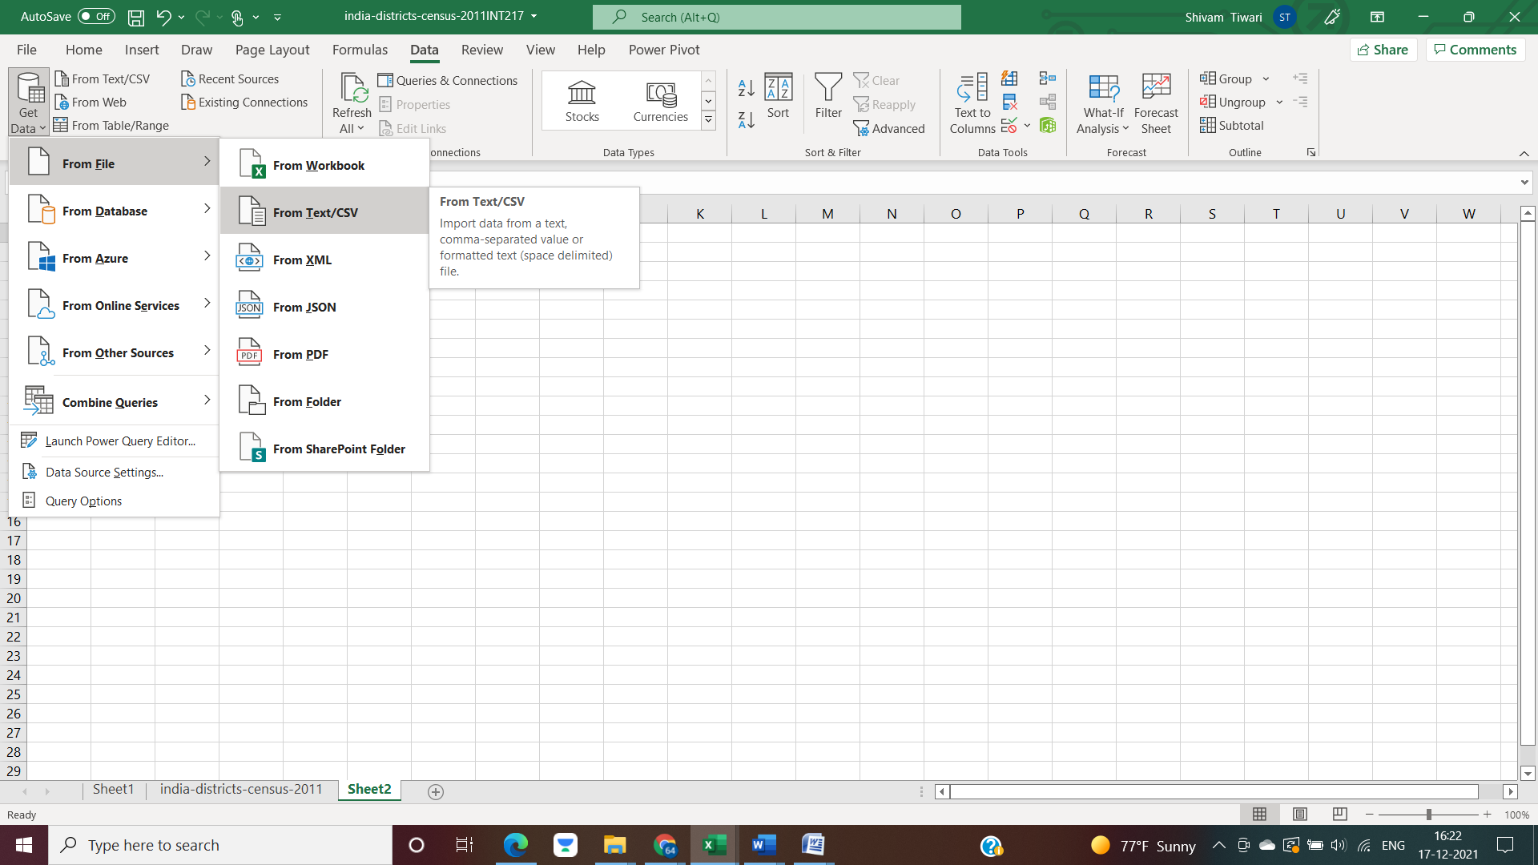

* Select the CSV file and load the data

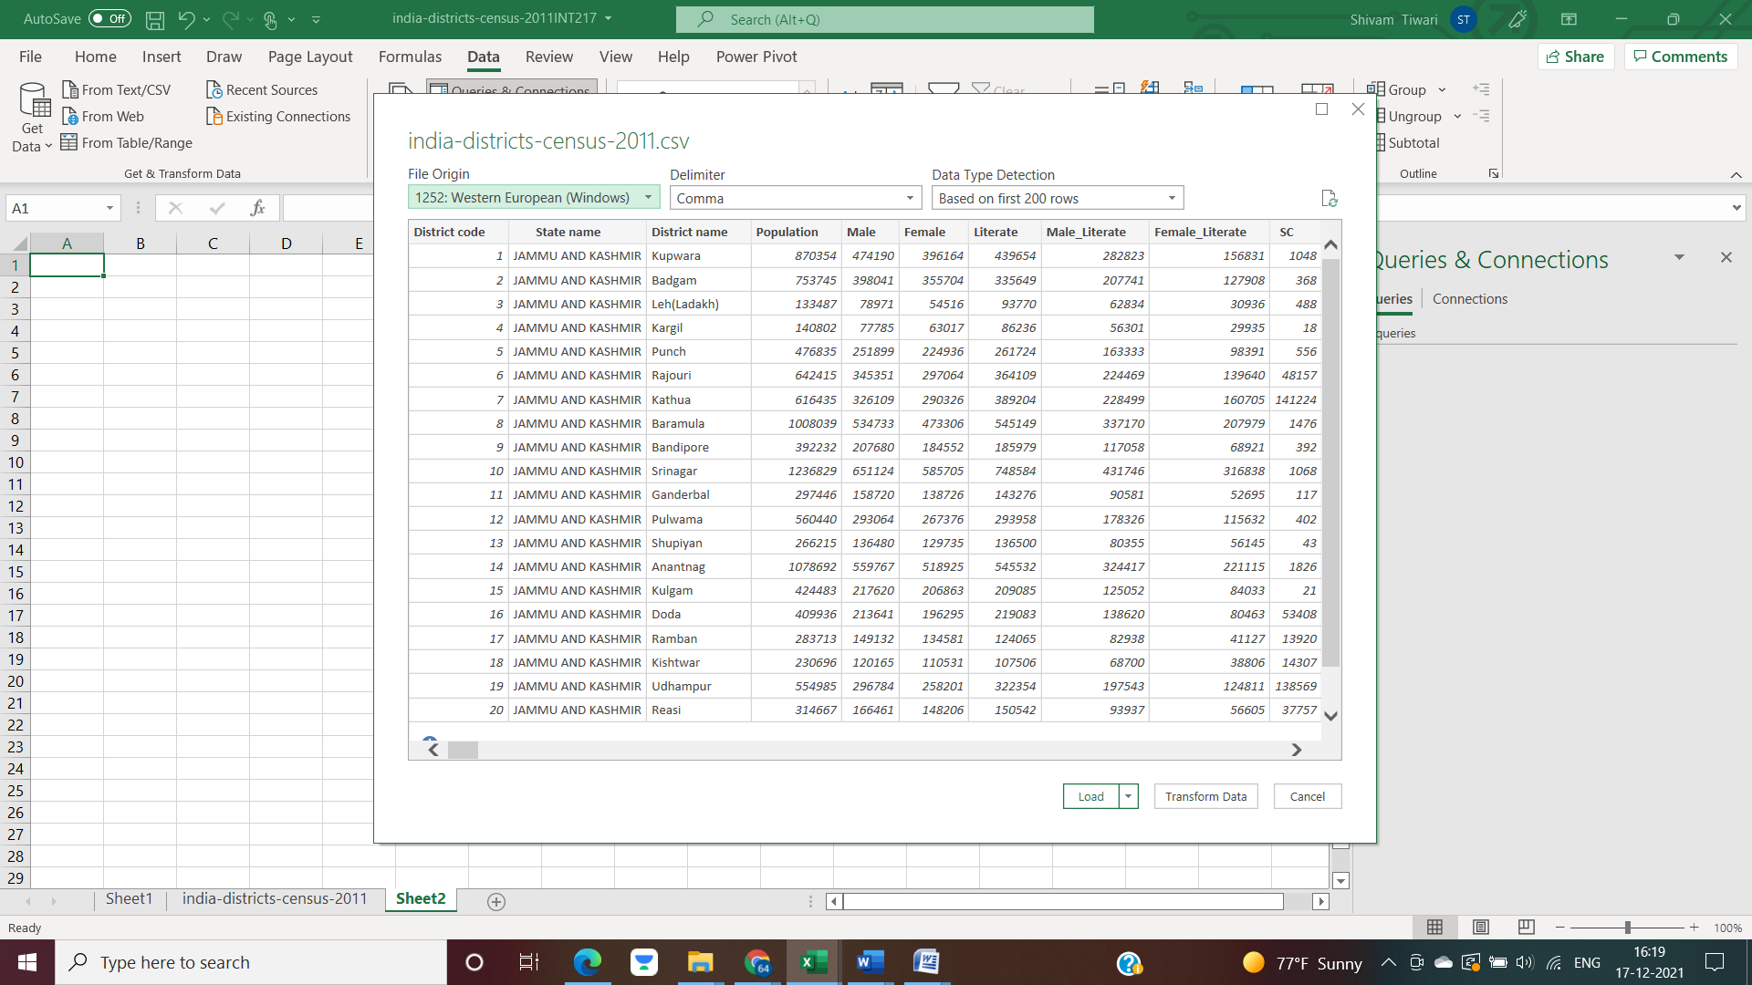

* The raw dataset will look like as shown:

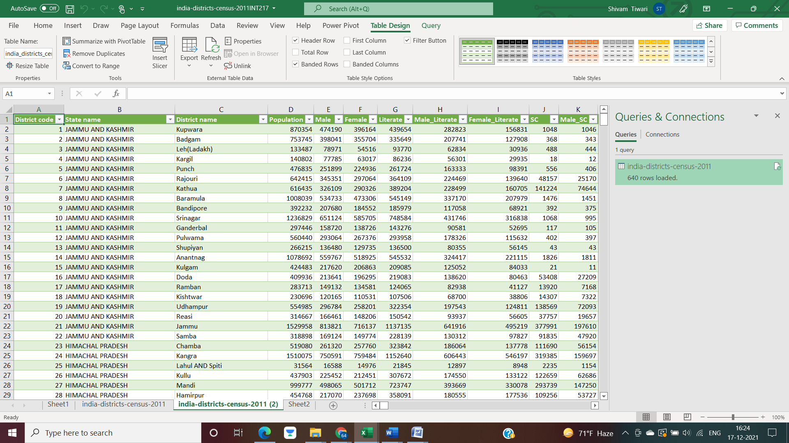

* The details of the dataset can be seen systematically.

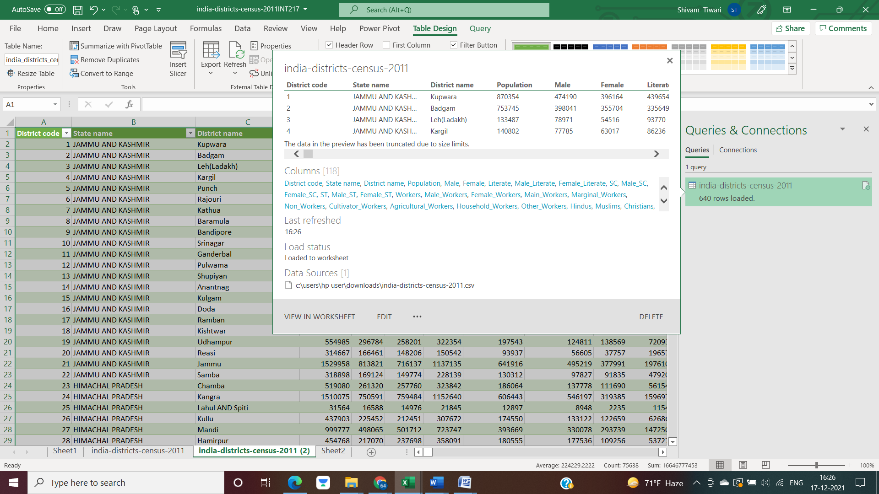

* We can change, modify and delete dataset according to the need of our analysis as well.

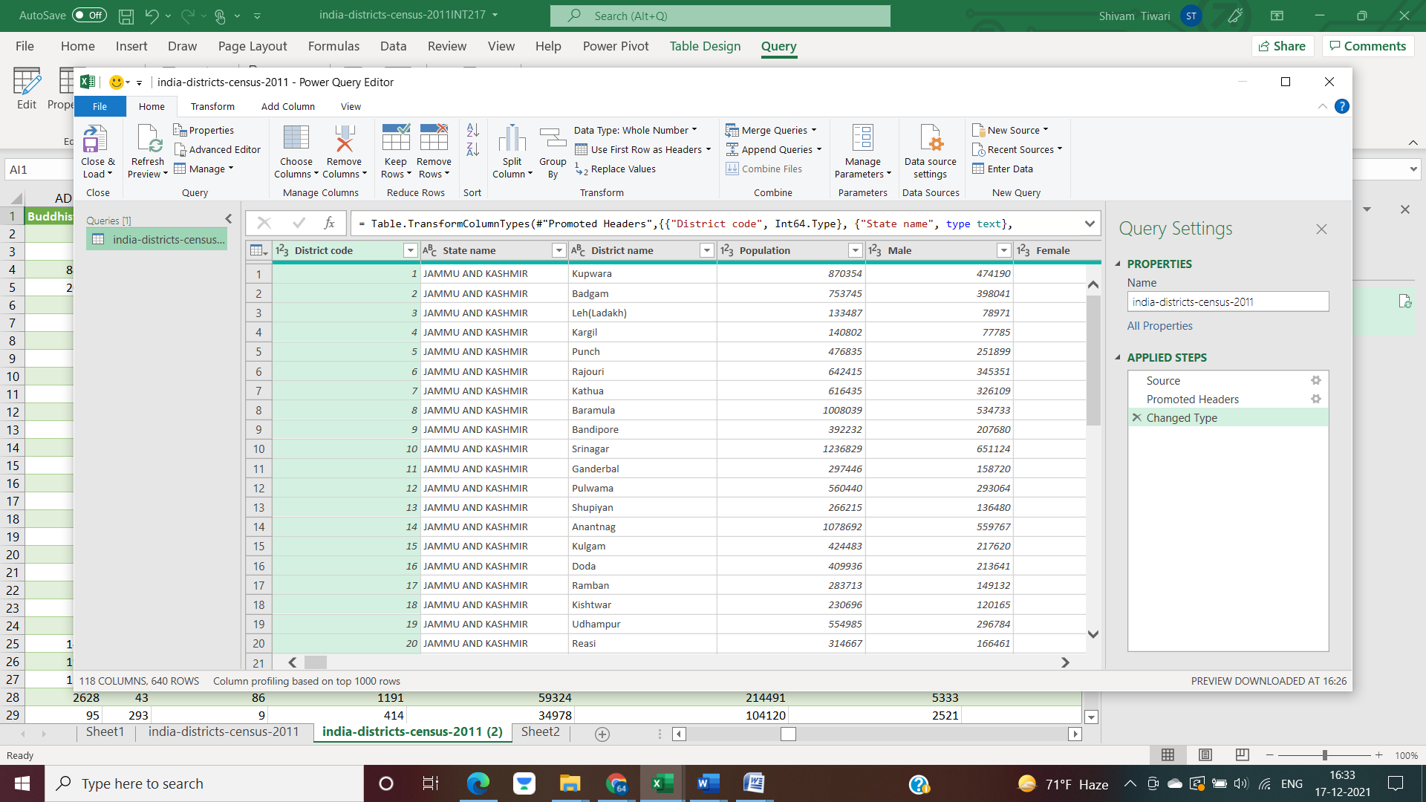

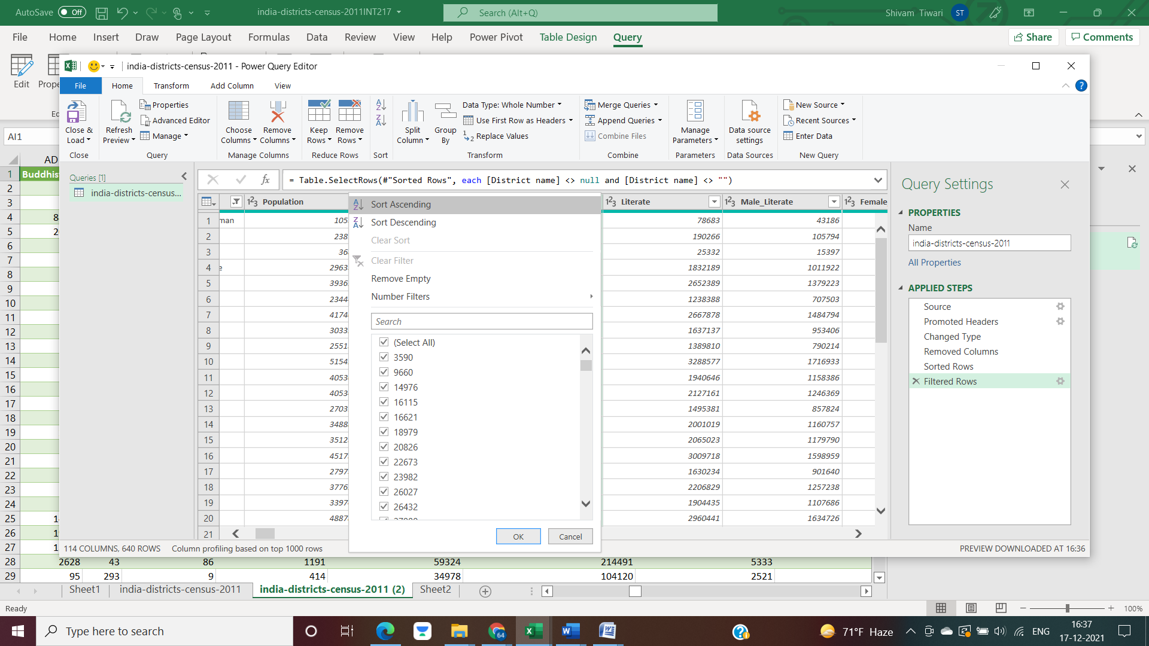

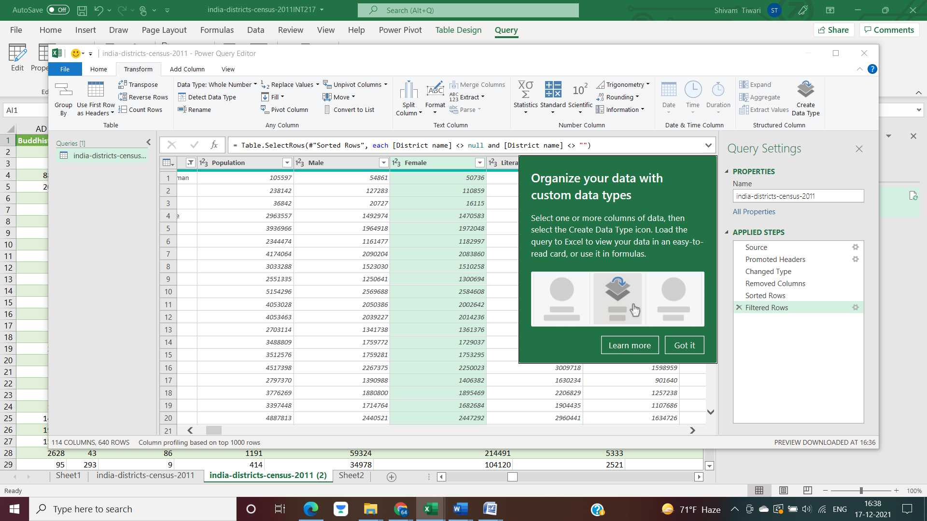

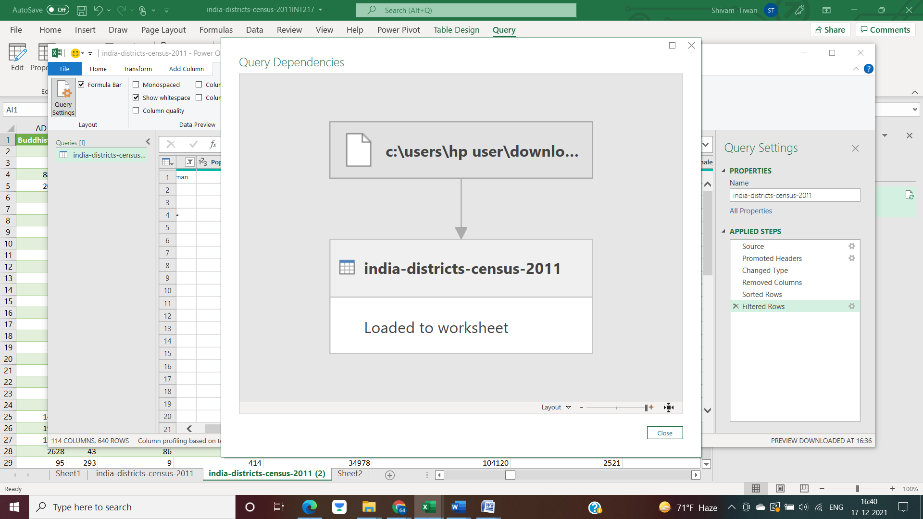

* After performing all these transformations, we can simply load it to worksheet.

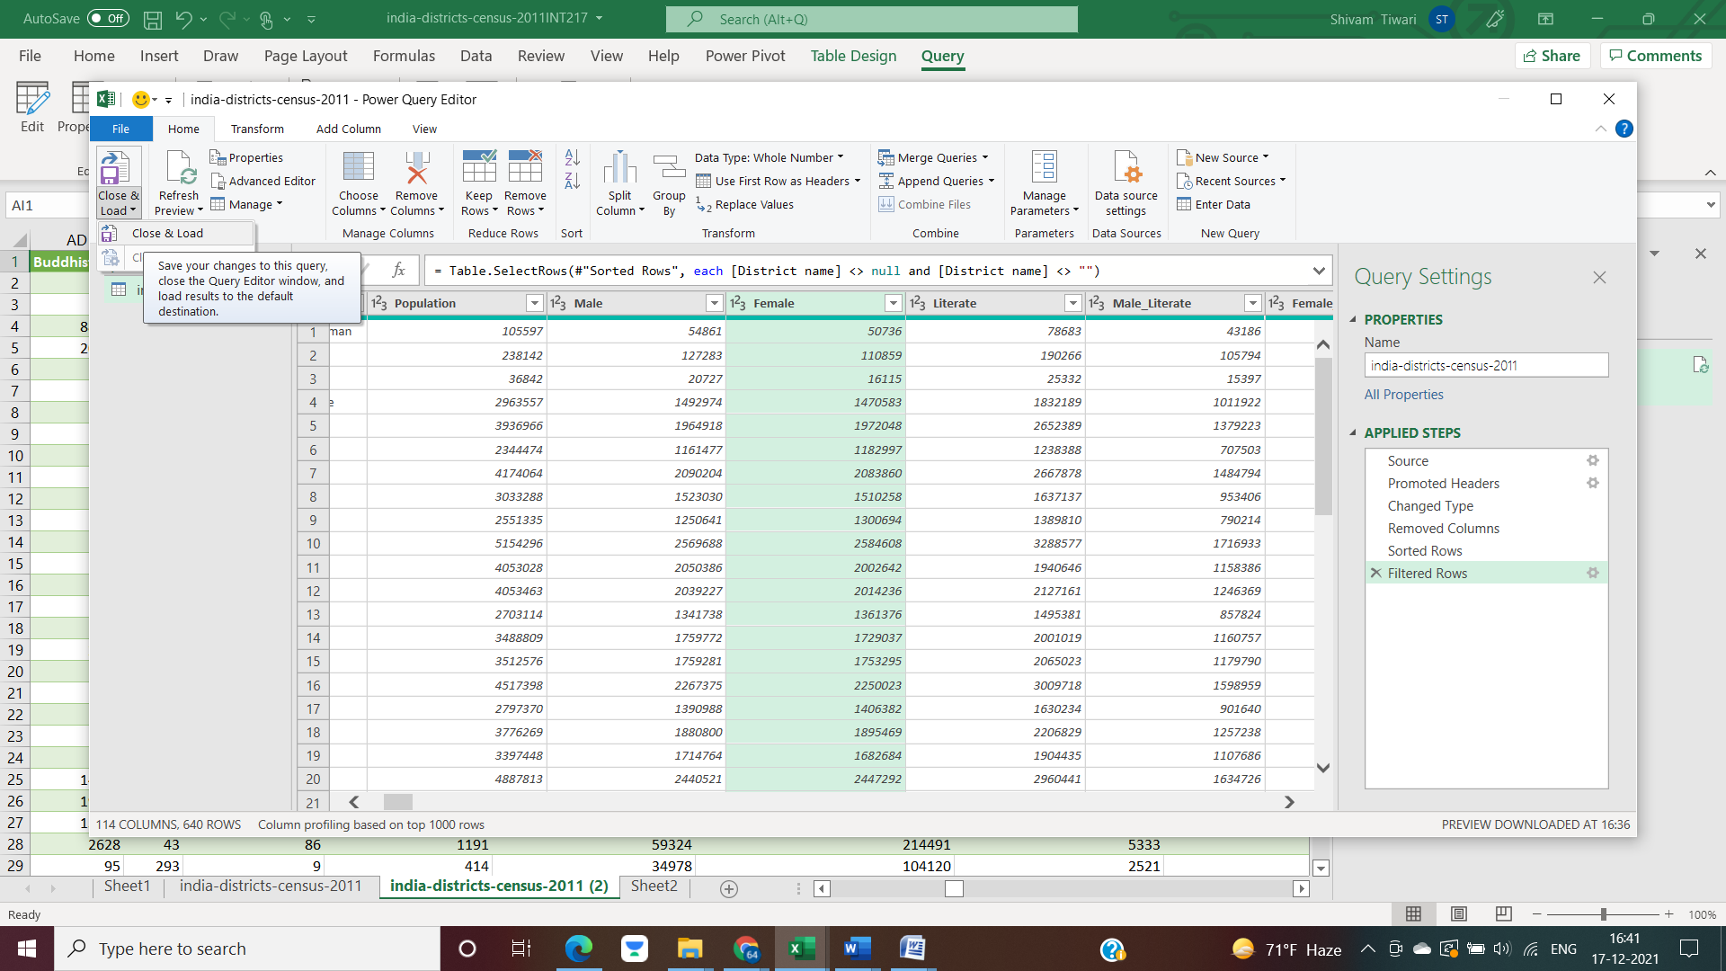

* The loaded sheet will appear as:

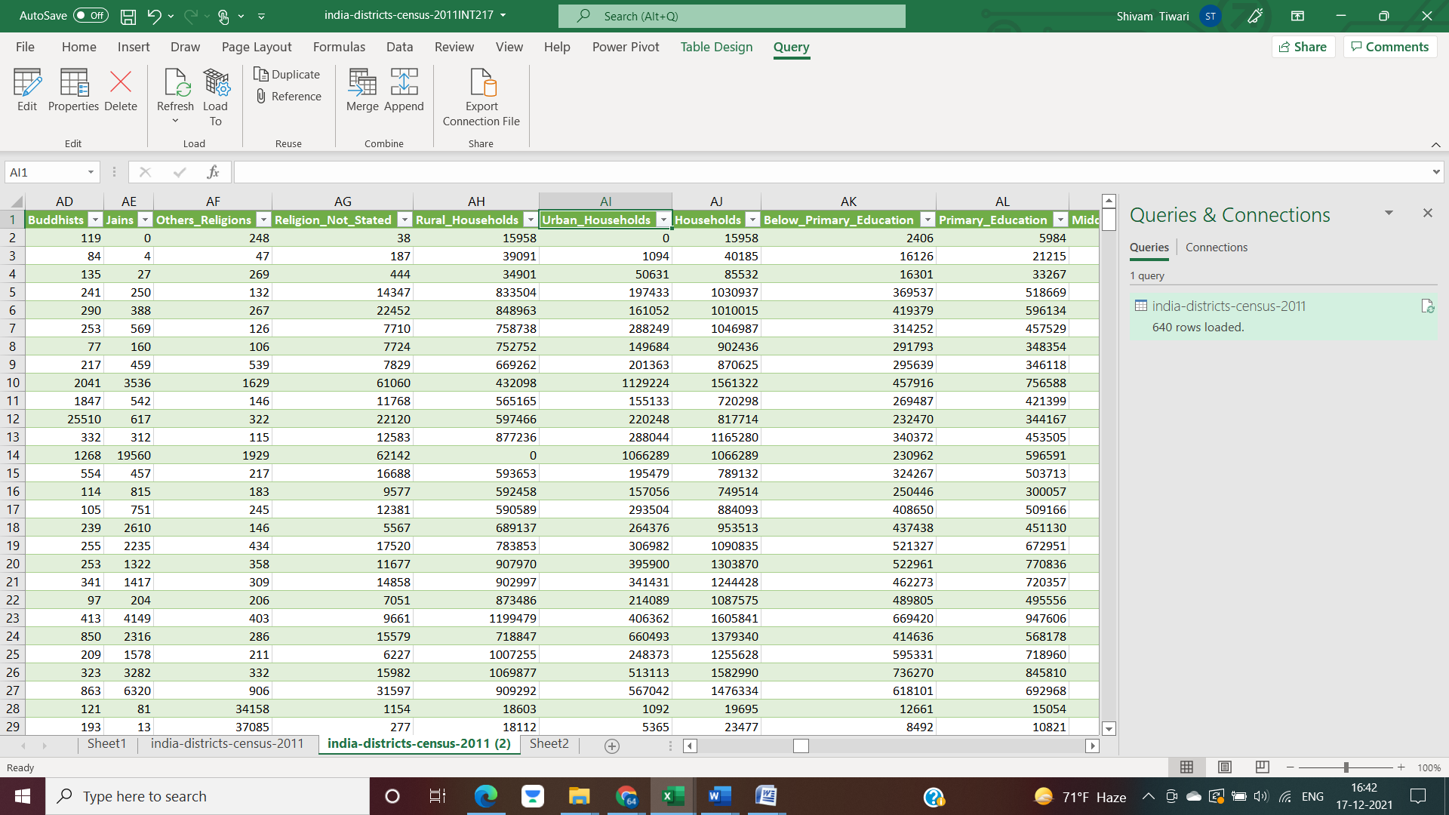

* Now, we can manage the transformed data model as shown in the picture.

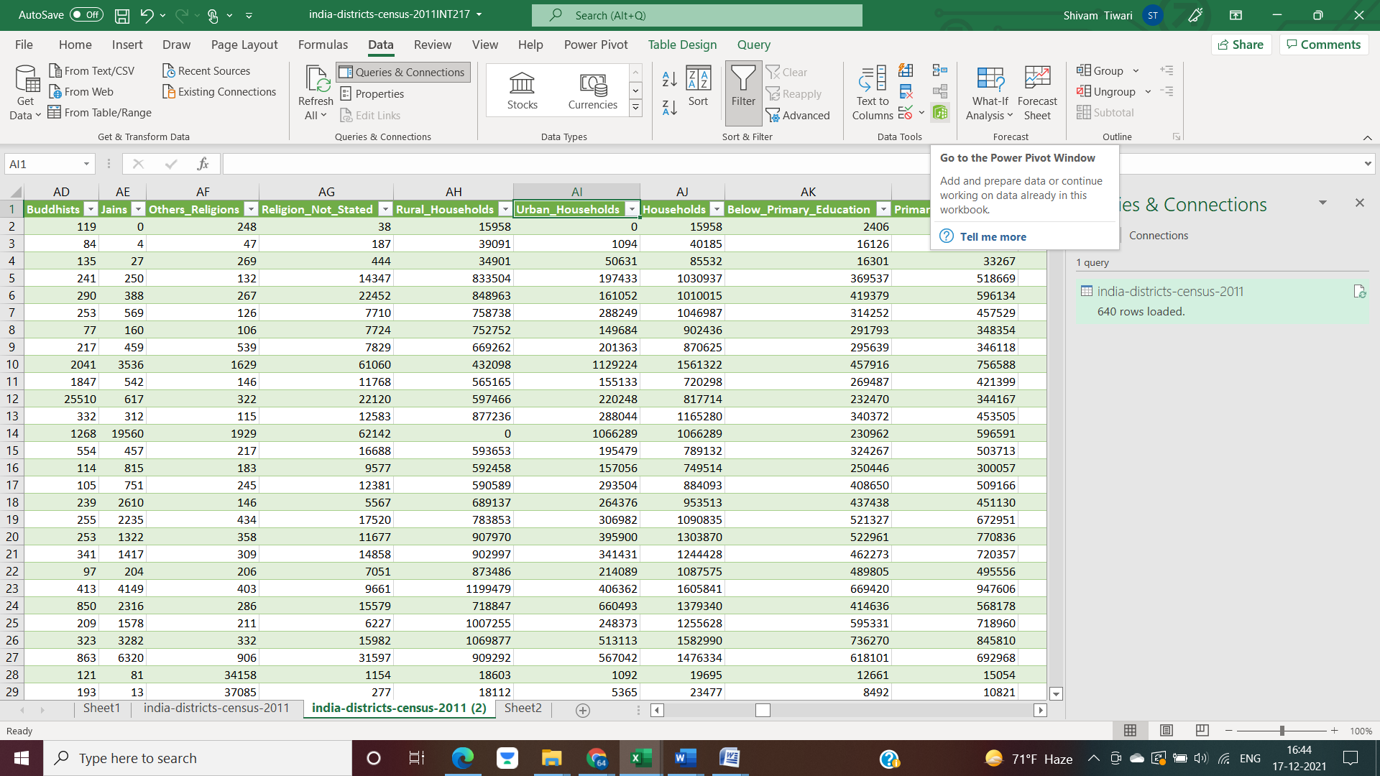

* It will appear as:



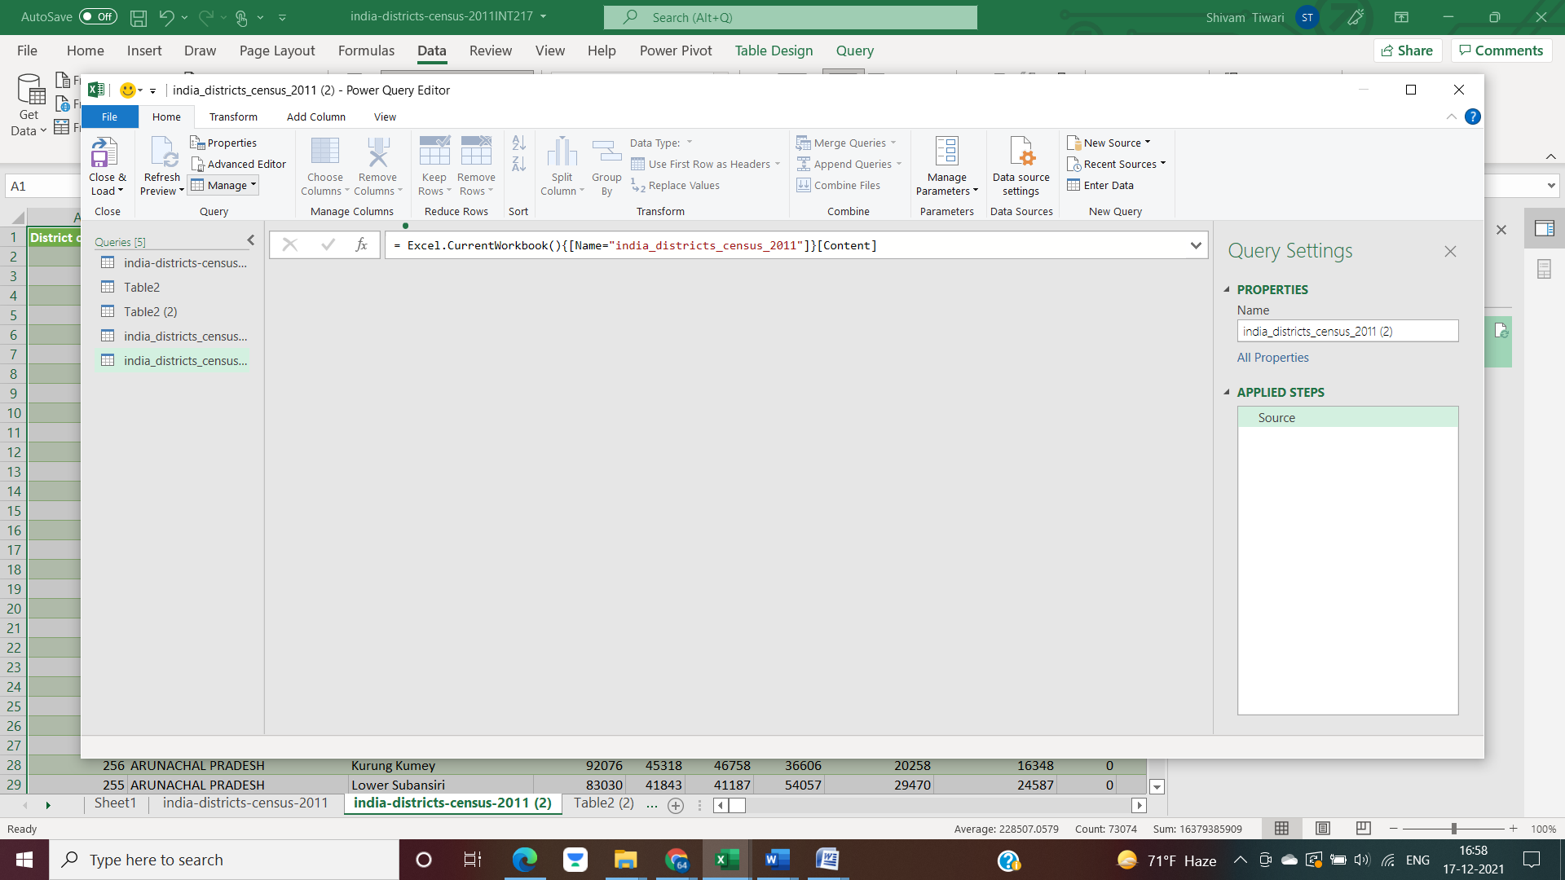

* We can analyse the transformed dataset as:

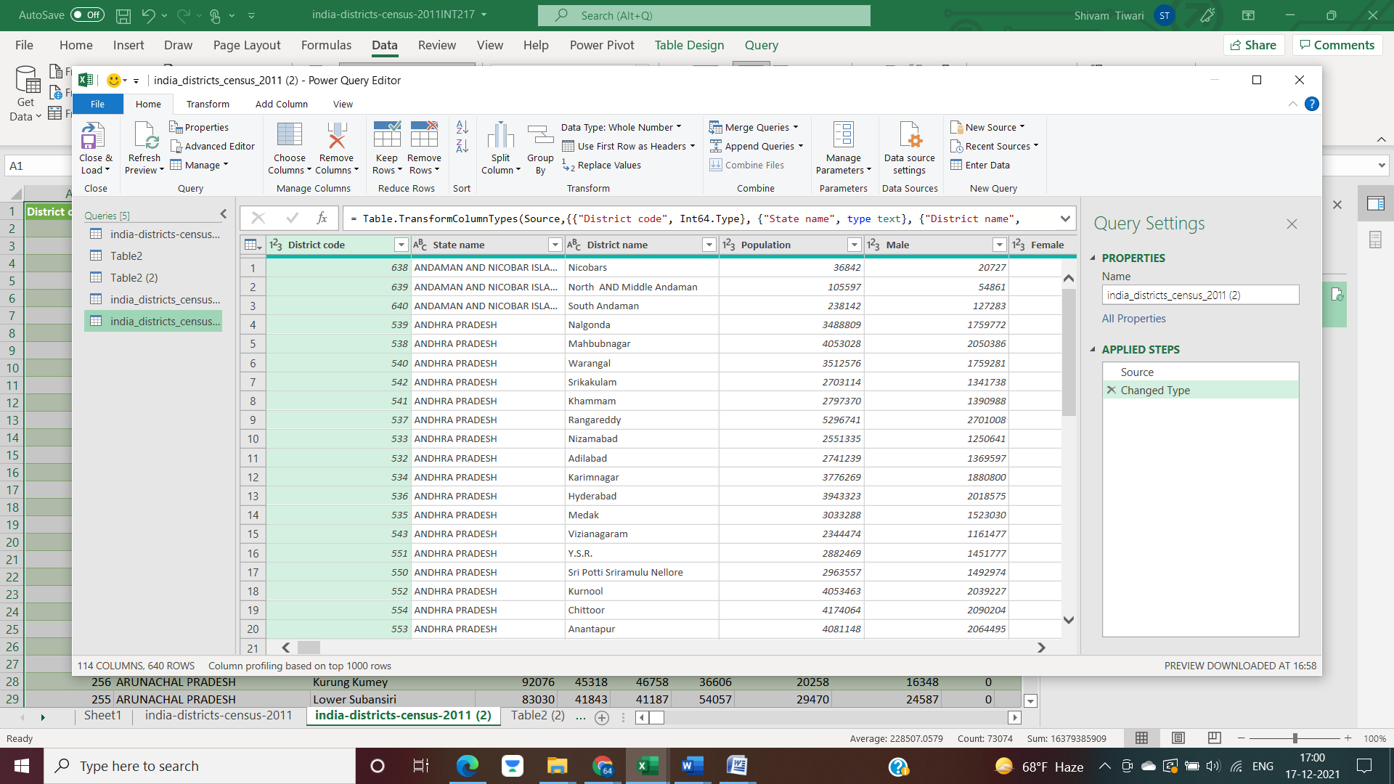

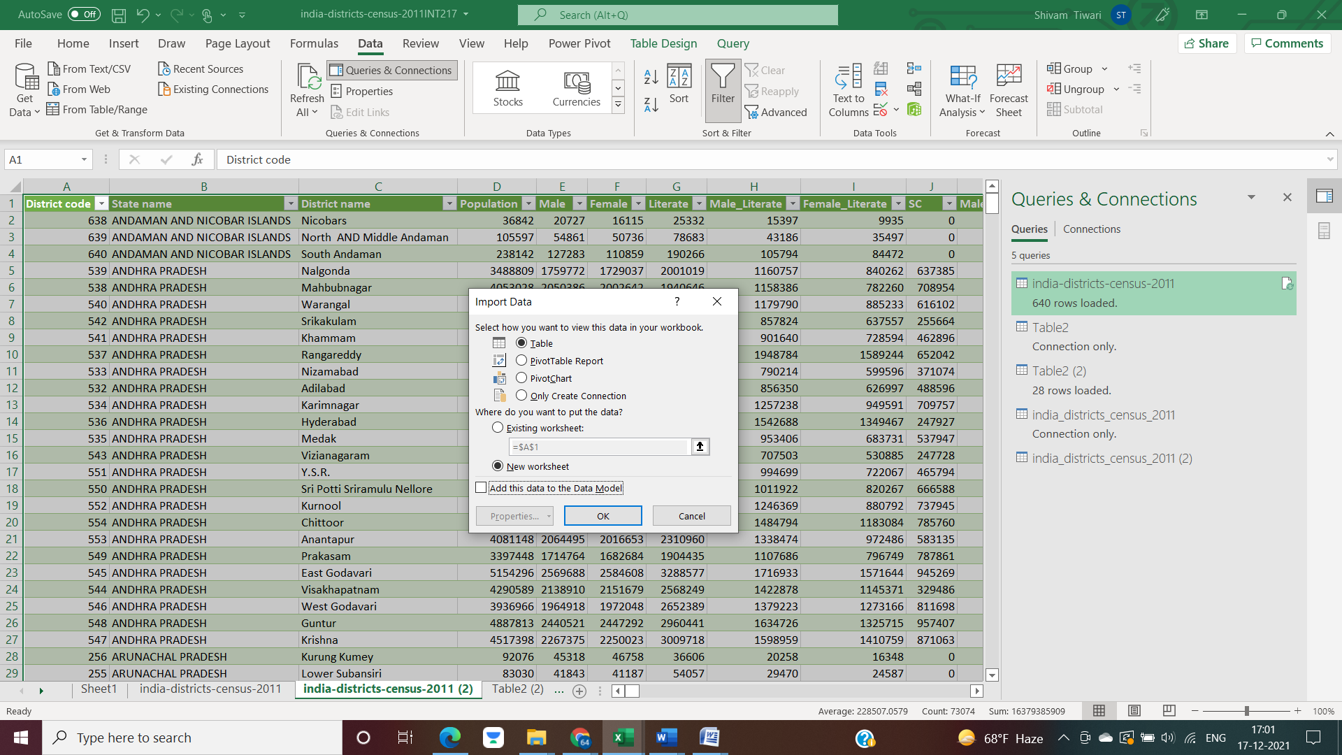

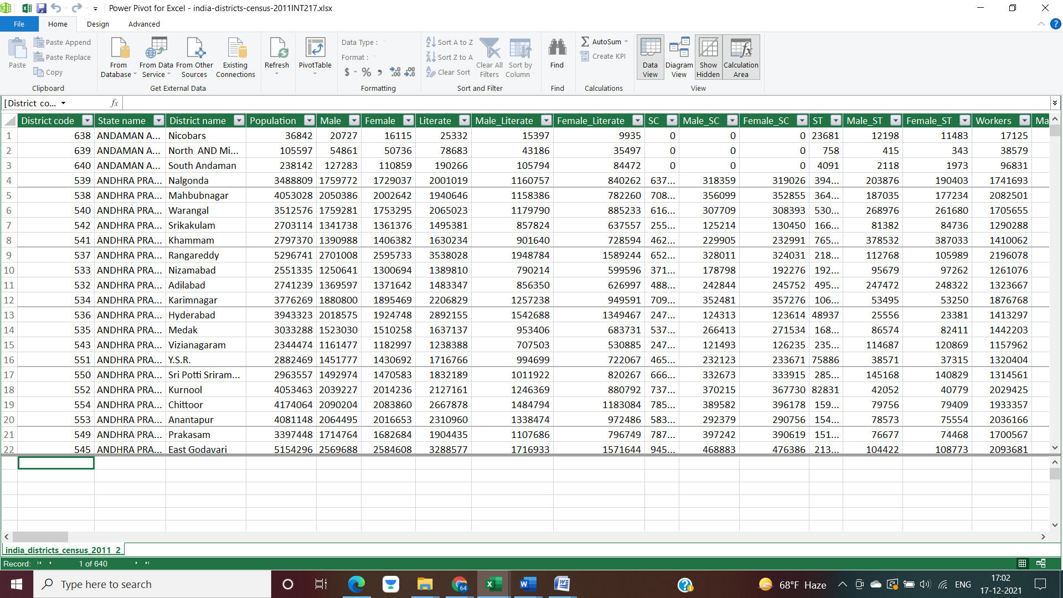

* On clicking on the diagram model, we can see and analyse the different data models as:

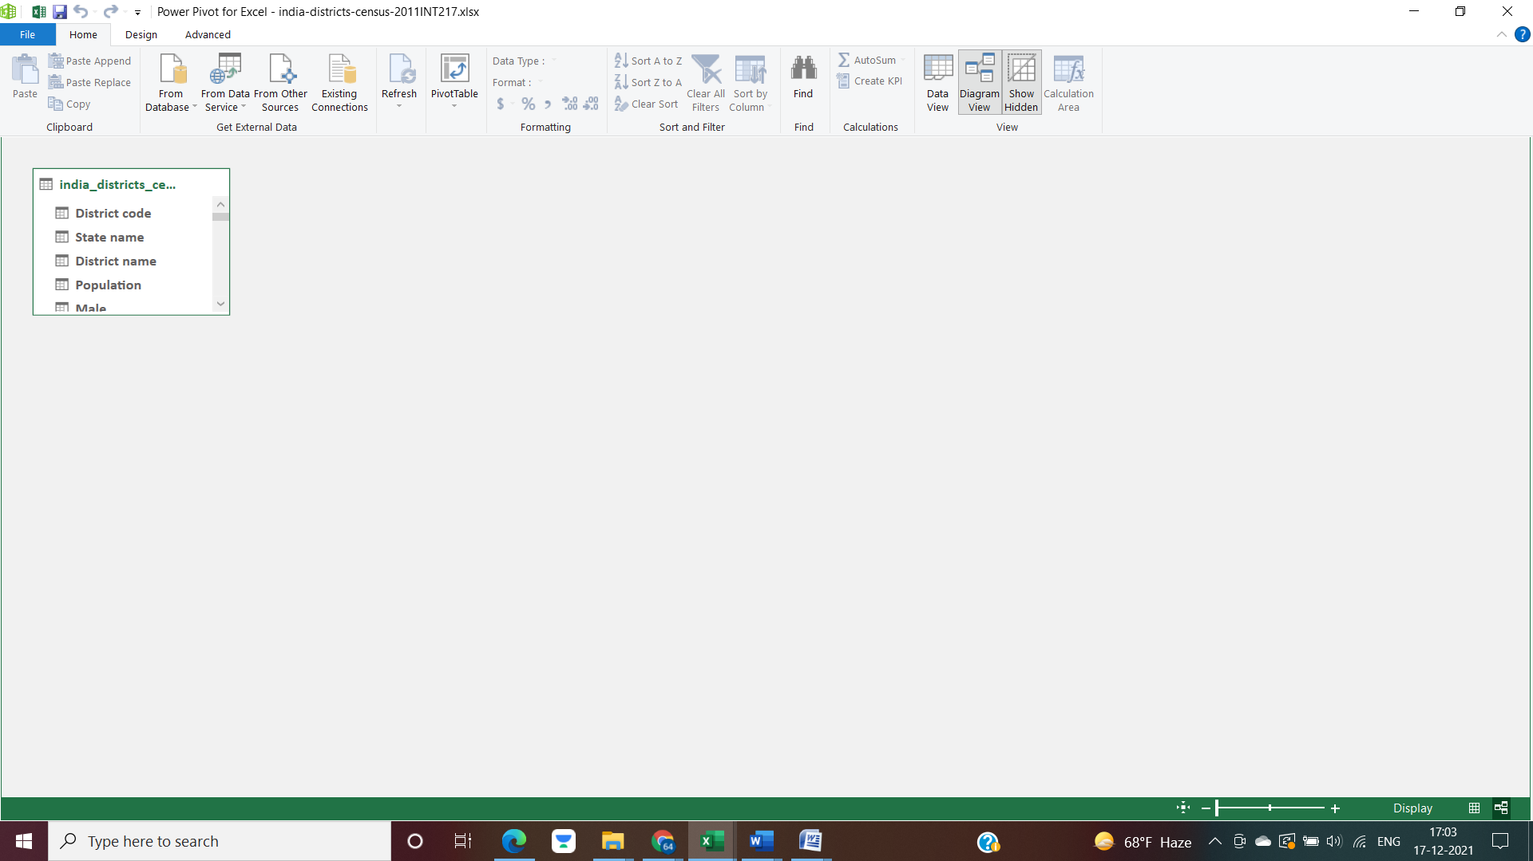

* We can also merge two different queries in ETL for better results.

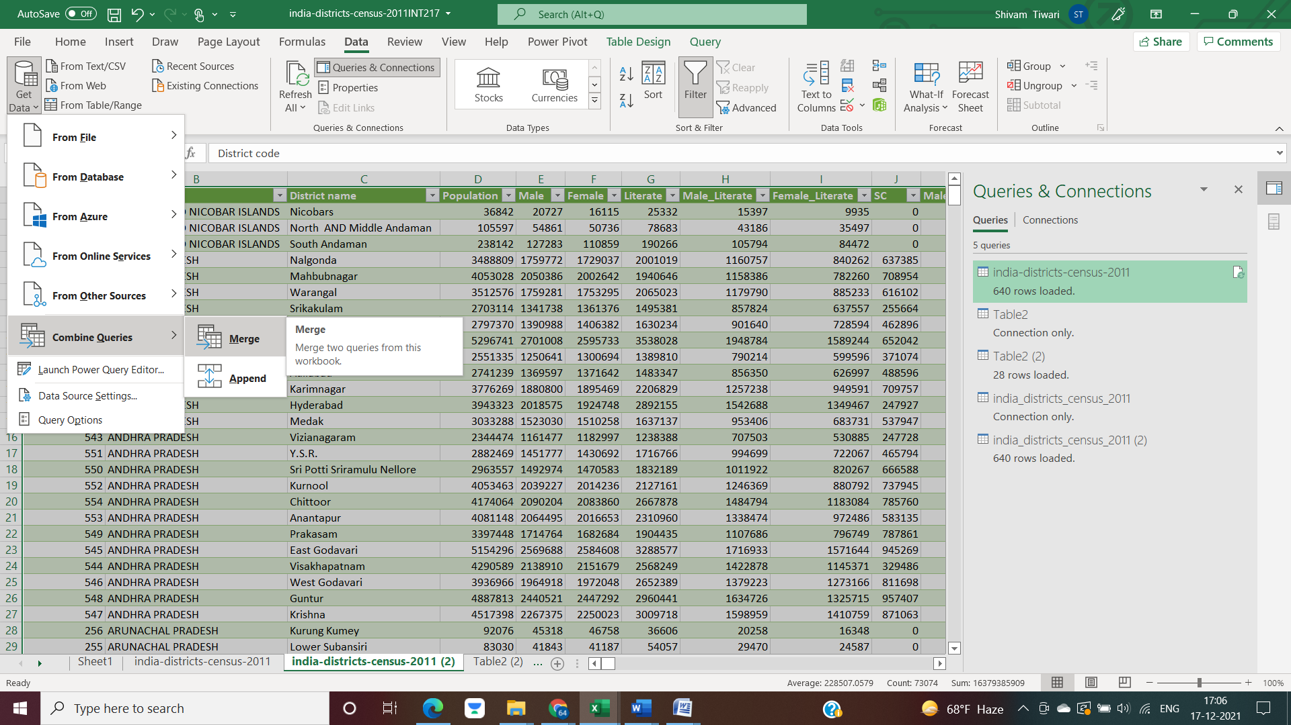

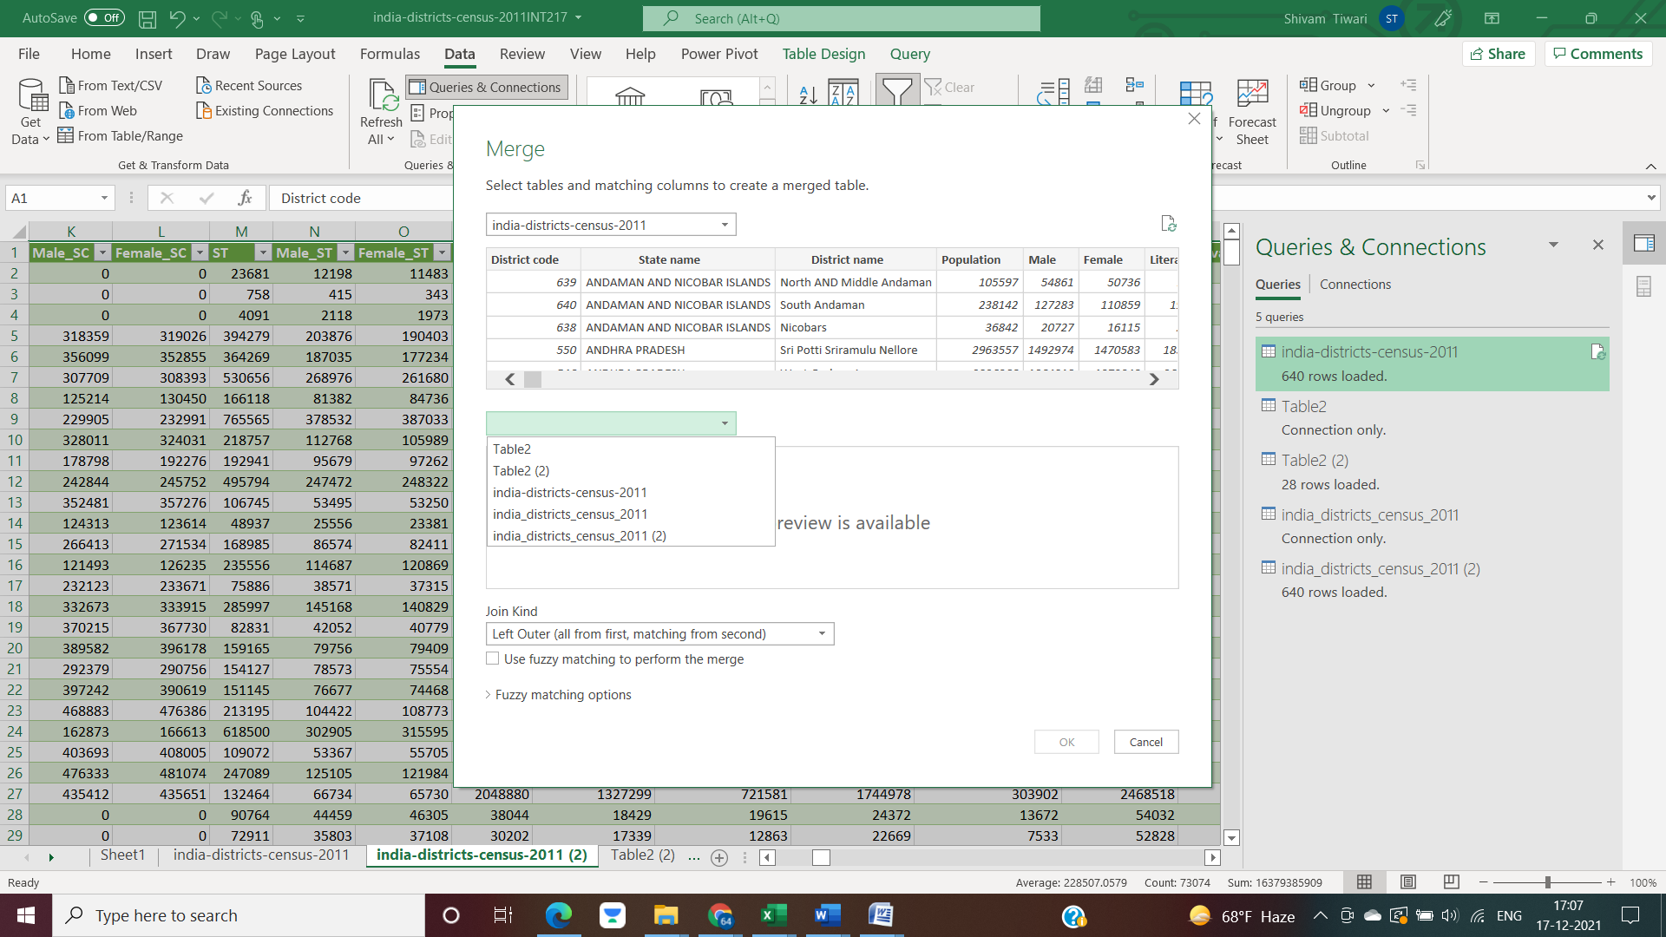

* For an example, let us discuss on a dataset derived from the following dataset.

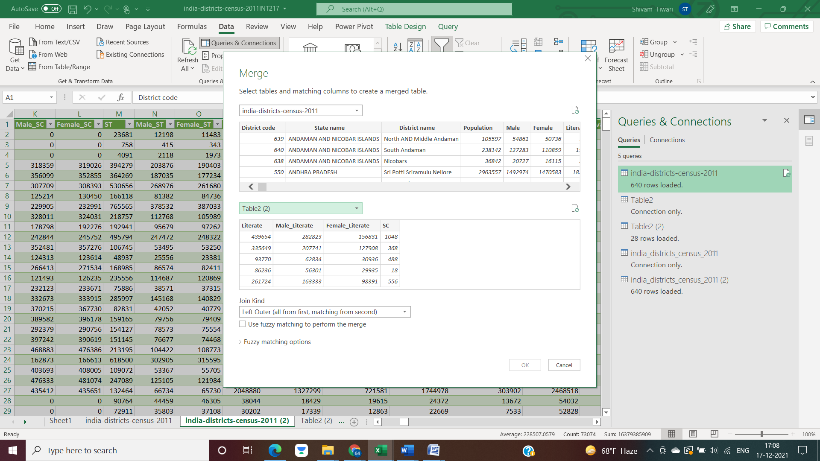

* After selecting the same type of columns either alphabetical or numerical from both the tables, we can proceed.

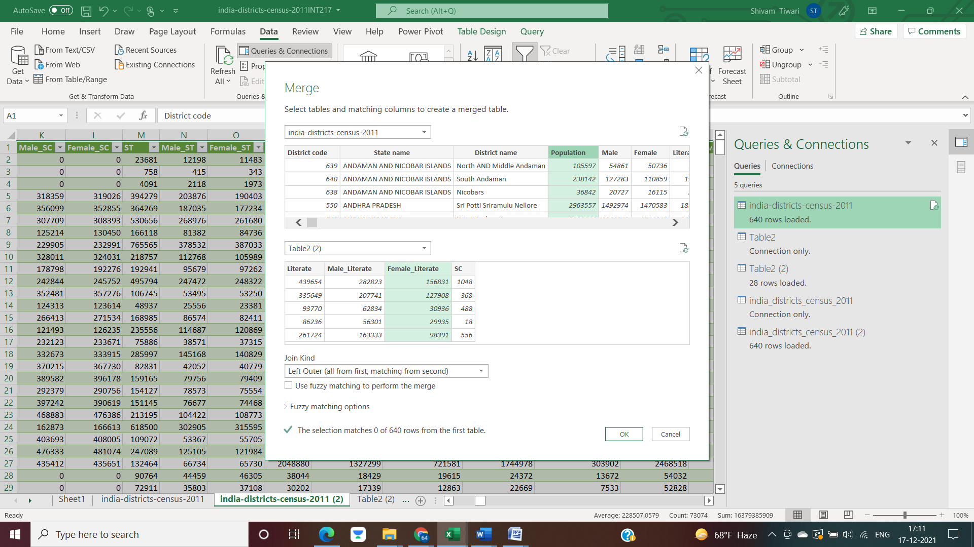

* Finally, the obtained data will appear as:

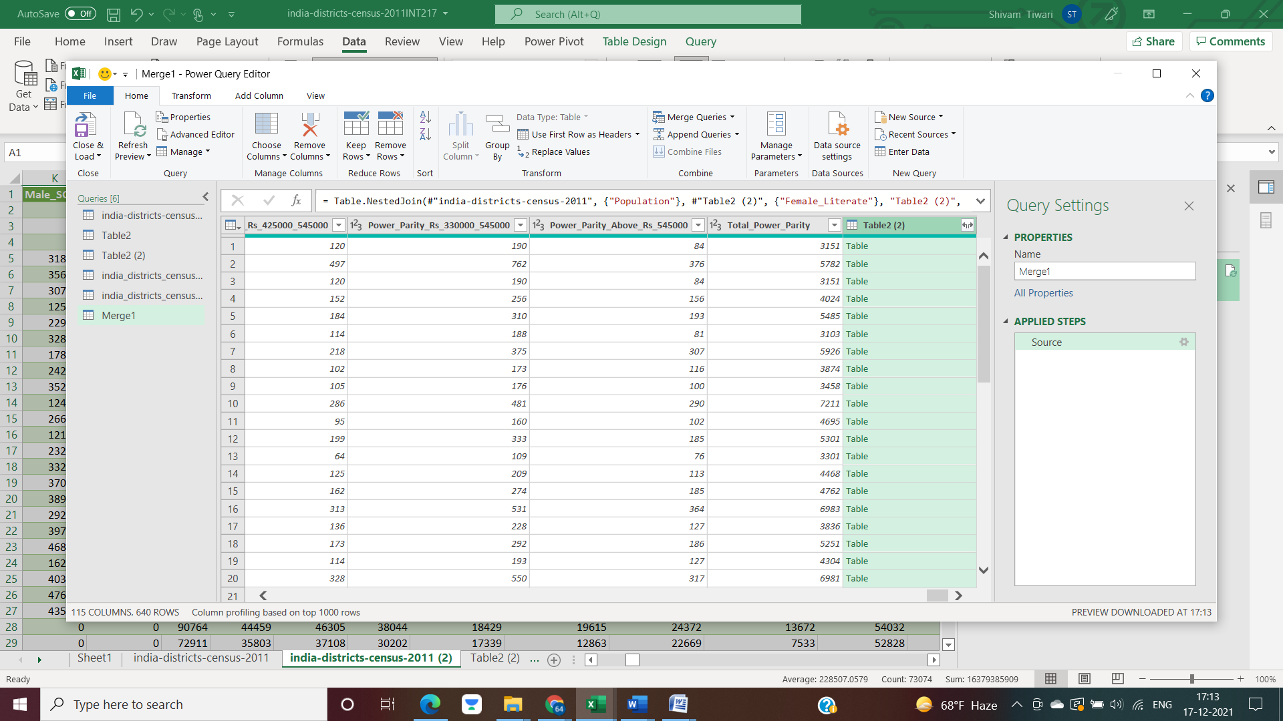

This is just a sample operation. Similarly, we can do more such operations using ETL that is Extract, Transform and Load.

**Analysis on the Dataset**

**Obj 1**

**District-wise and state-wise population**

**Introduction**

By doing this analysis, we are able to find district wise and state wise population data in tabular and pictorial form.

**Description**

The analysis will show the district wise population data of each and every state.

**Specific Requirements, functions and formulas**

We found the desired results by introducing pivot table and respective charts so that we can find the desired results systematically after selecting the states from the table.

We have also found top 5 districts and population using the XLOOKUP and functions and the formulas as below:

* **=XLOOKUP(LARGE($B$4:$B$41,ROWS($Q$5:$Q5)),$B$4:$B$41,$A$4:$A$41)**
* **=LARGE($B$4:$B$41,ROWS($S$4:$S6))**

**Analysis Results**

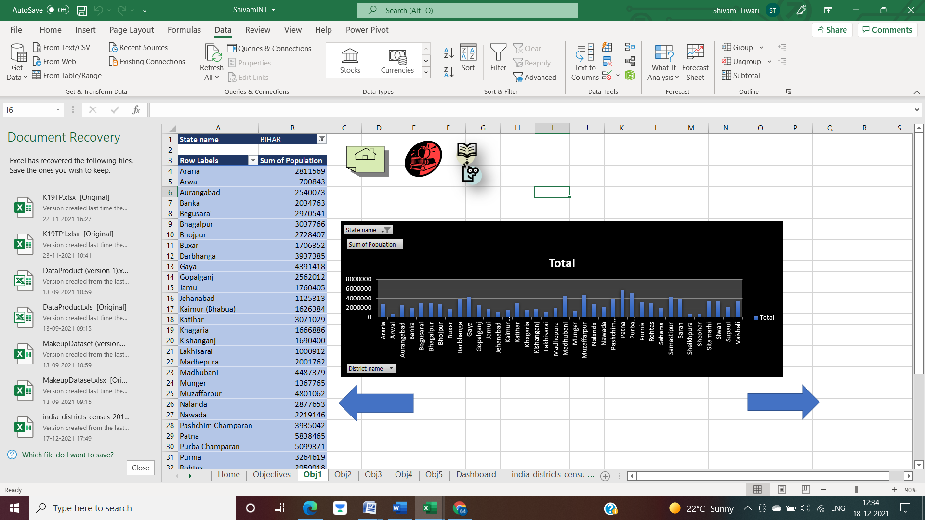

If we talk about Bihar, we have obtained top 5 districts as:

* Patna
* Purbi Champaran
* Muzaffarpur
* Madhubani
* Gaya

Similar data can be calculated for other states as well.

**Visualization**

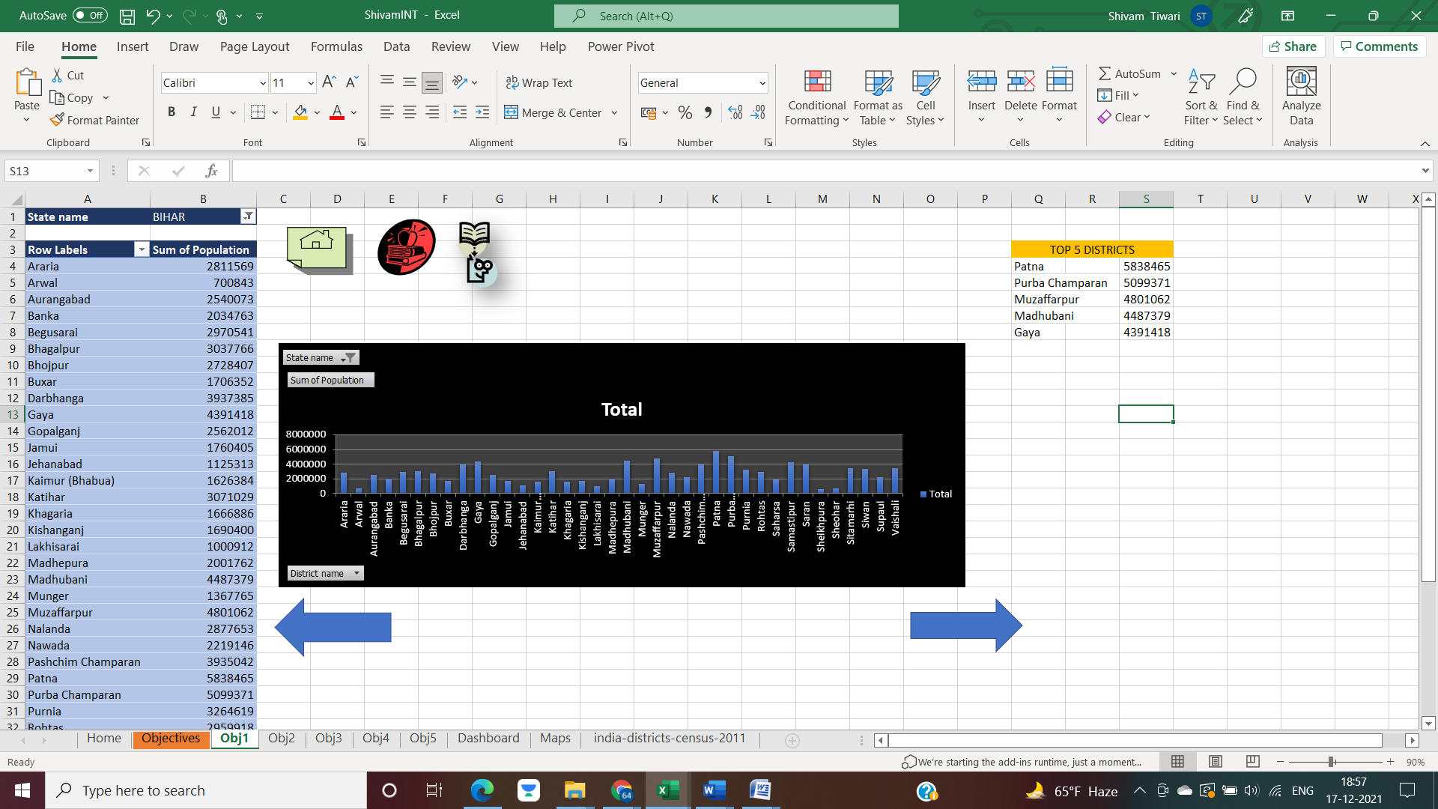

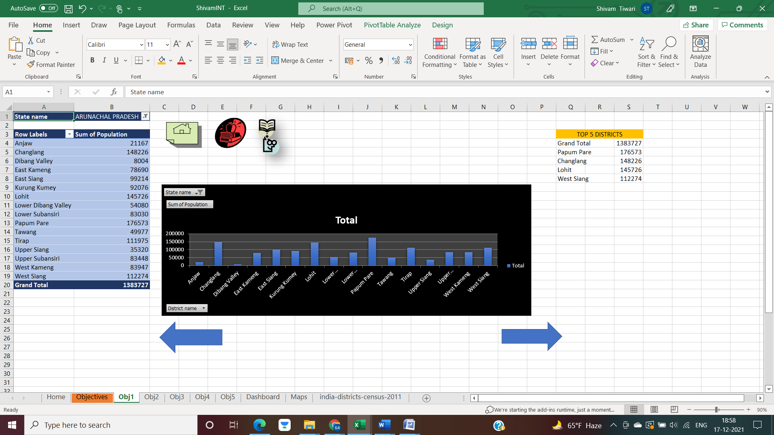

The figures above are showing examples of only two states, Bihar and Arunachal Pradesh. We can derive the same charts and data for any of the given states.

**OBJ2**

**Sum of male and female population**

**Introduction**

By doing this analysis, we are able to find male and female population data in tabular and pictorial form.

**Description**

The analysis will show the male and female population of different states along with pivot chart.

**Specific Requirements, functions and formulas**

We found the desired results by introducing pivot table and respective charts so that we can find the desired results systematically after selecting the states from the table.

Pivot table is used for the analysis. Sum function is used in pivot table for the sum of the revenues in the pivot table.

**Analysis Result**

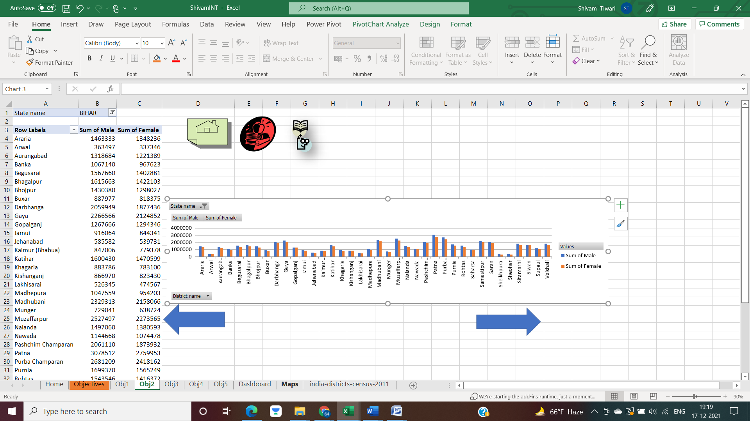

**Visualization**

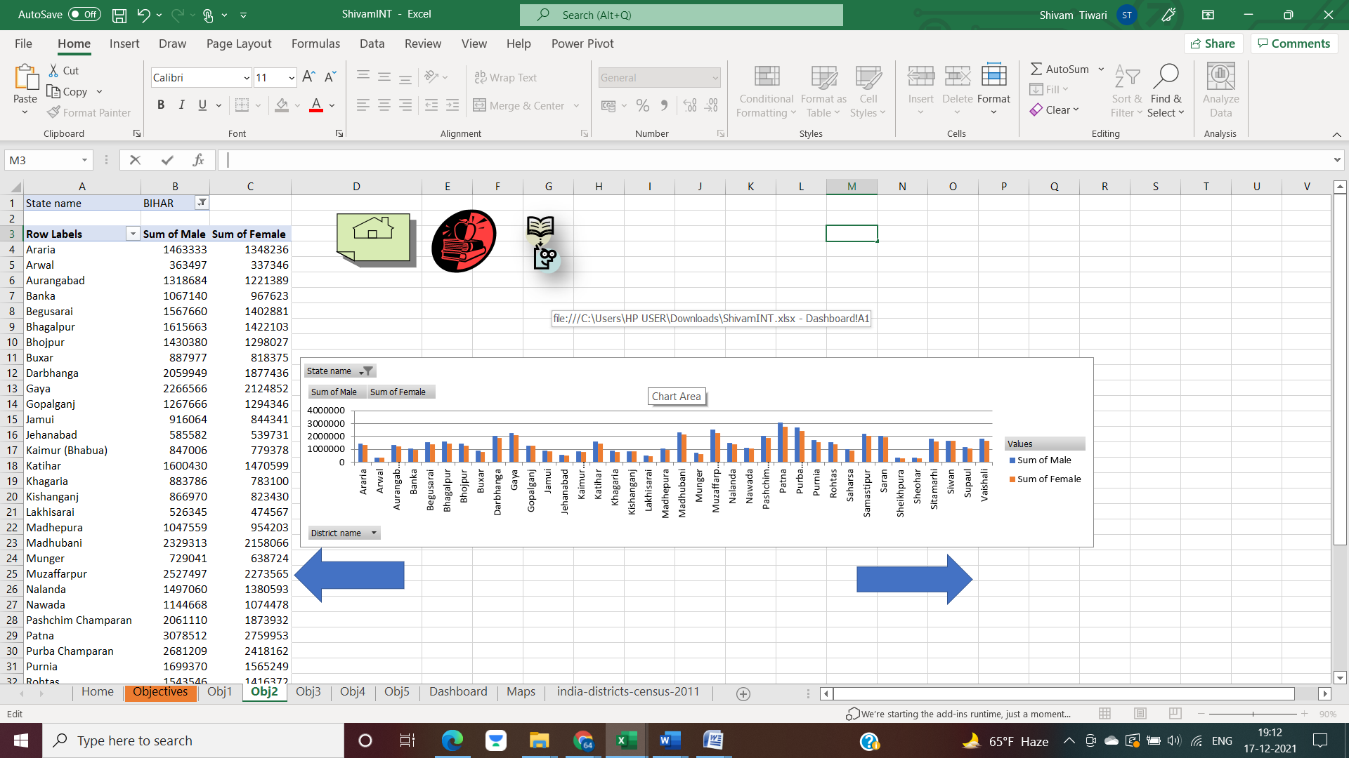

**OBJ3**

**Total Literate Population**

**Introduction**

By doing this analysis, we are able to find total literate population data in tabular and pictorial form.

**Description**

The analysis will show the literate population of different states along with pivot chart.

**Specific Requirements, functions and formulas**

We found the desired results by introducing pivot table and respective charts so that we can find the desired results systematically after selecting the states from the table.

Pivot table is used for the analysis. Sum function is used in pivot table for the sum of the revenues in the pivot table.

**Result Analysis**

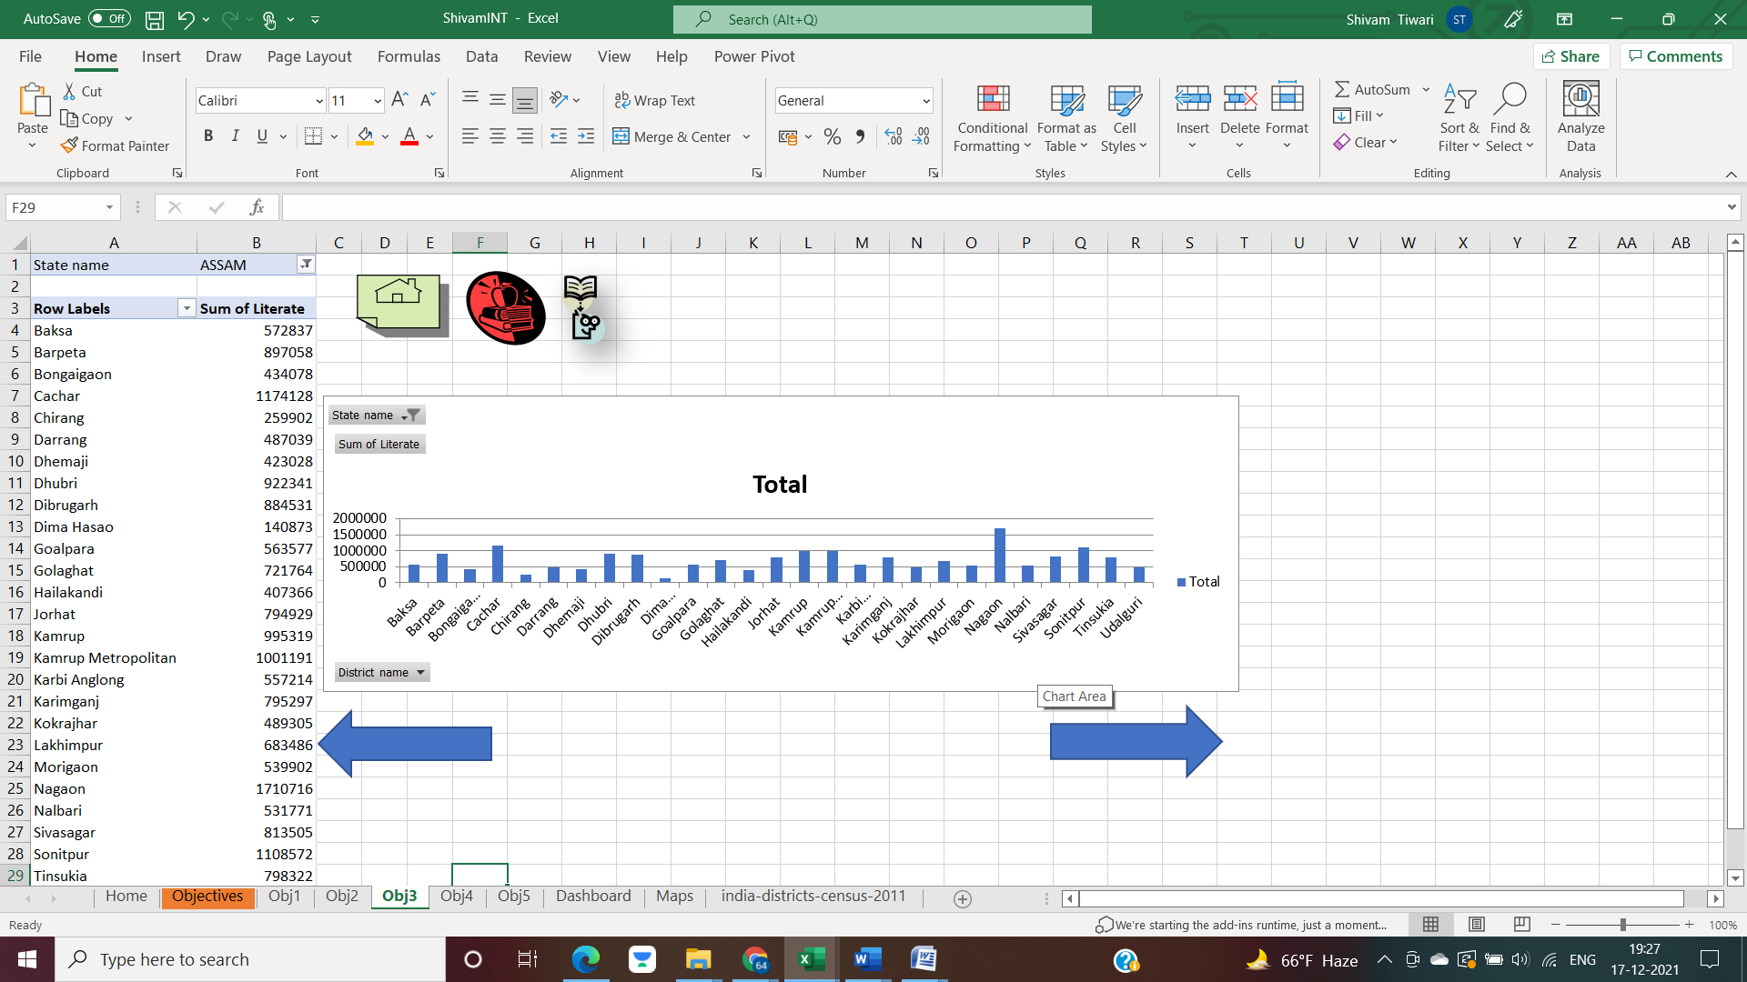

**Visualization**

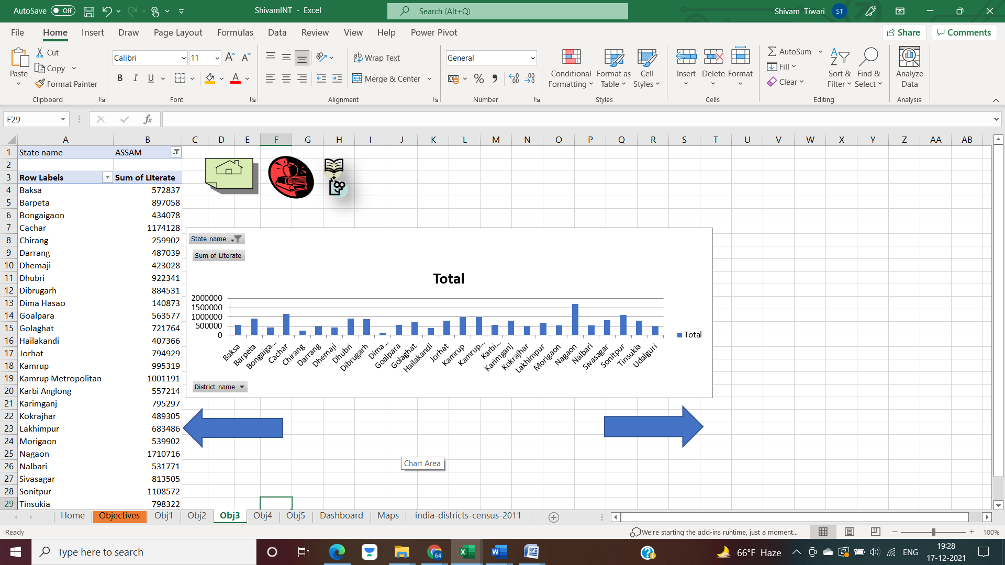

**OBJ4**

**People of different age groups**

**Introduction**

By doing this analysis, we are able to find number of people of different age group in tabular and pictorial form.

**Description**

The analysis will show the different age groups of different states along with pivot chart.

**Specific Requirements, functions and formulas**

We found the desired results by introducing pivot table and respective charts so that we can find the desired results systematically after selecting the states from the table.

Pivot table is used for the analysis. Sum function is used in pivot table for the sum of the revenues in the pivot table.

**Result Analysis**

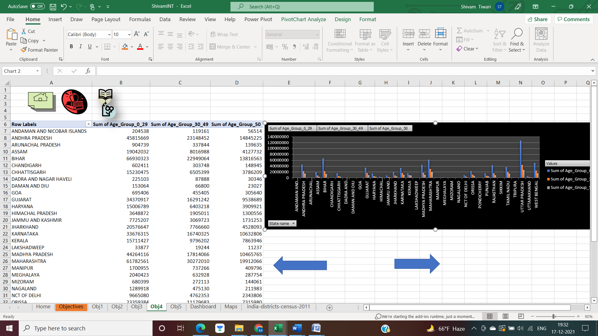

**Visualization**

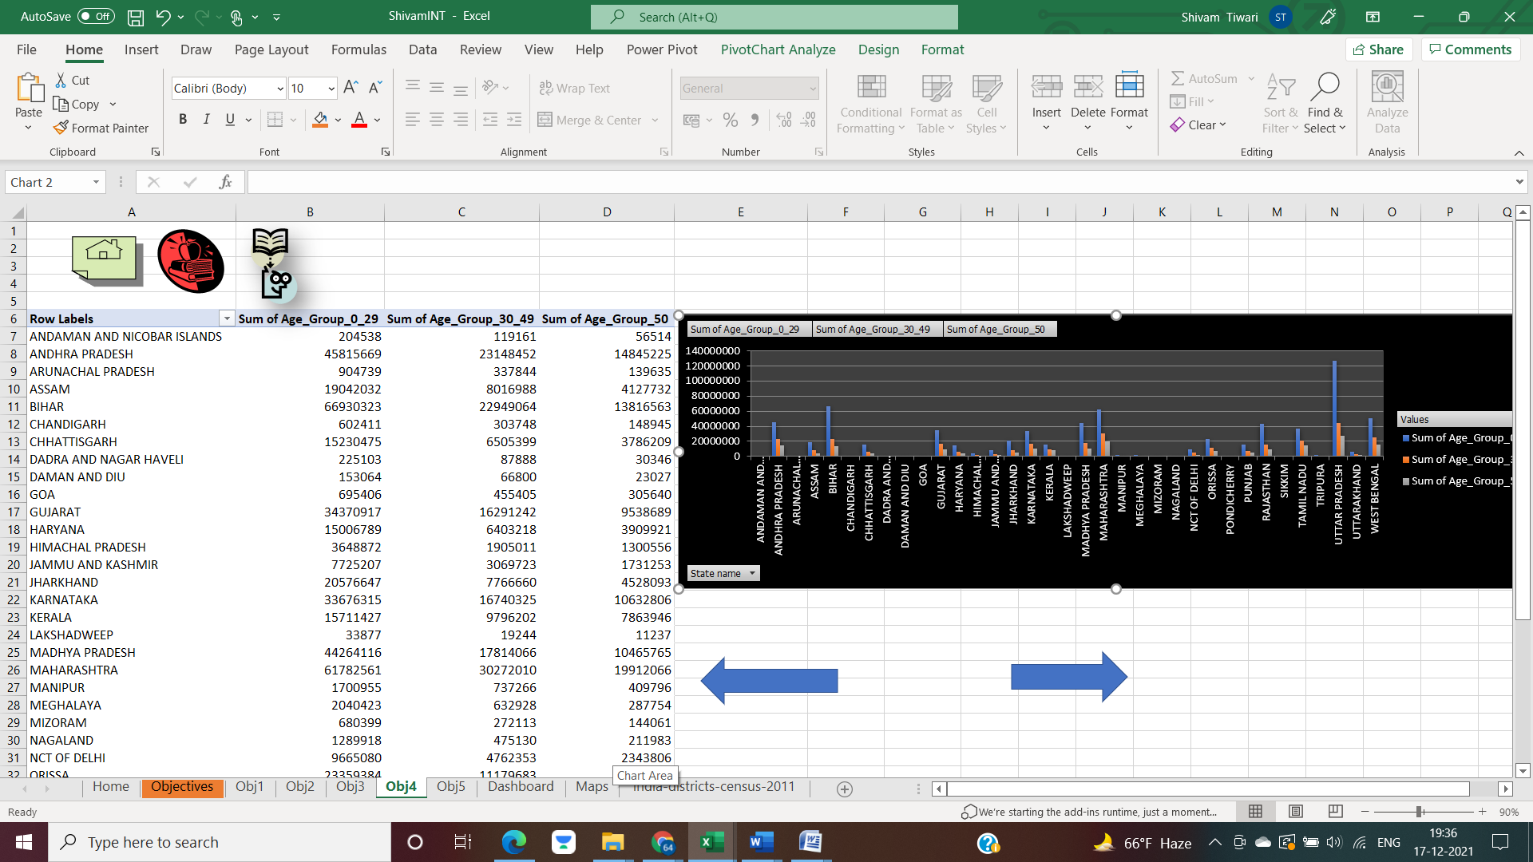

**OBJ5**

**People of different religions**

**Introduction**

By doing this analysis, we are able to find number of people of different religions in tabular and pictorial form.

**Description**

The analysis will show the different age groups of different religions along with pivot chart.

**Specific Requirements, functions and formulas**

We found the desired results by introducing pivot table and respective charts so that we can find the desired results systematically after selecting the states from the table.

Pivot table is used for the analysis. Sum function is used in pivot table for the sum of the revenues in the pivot table.

**Result Analysis**

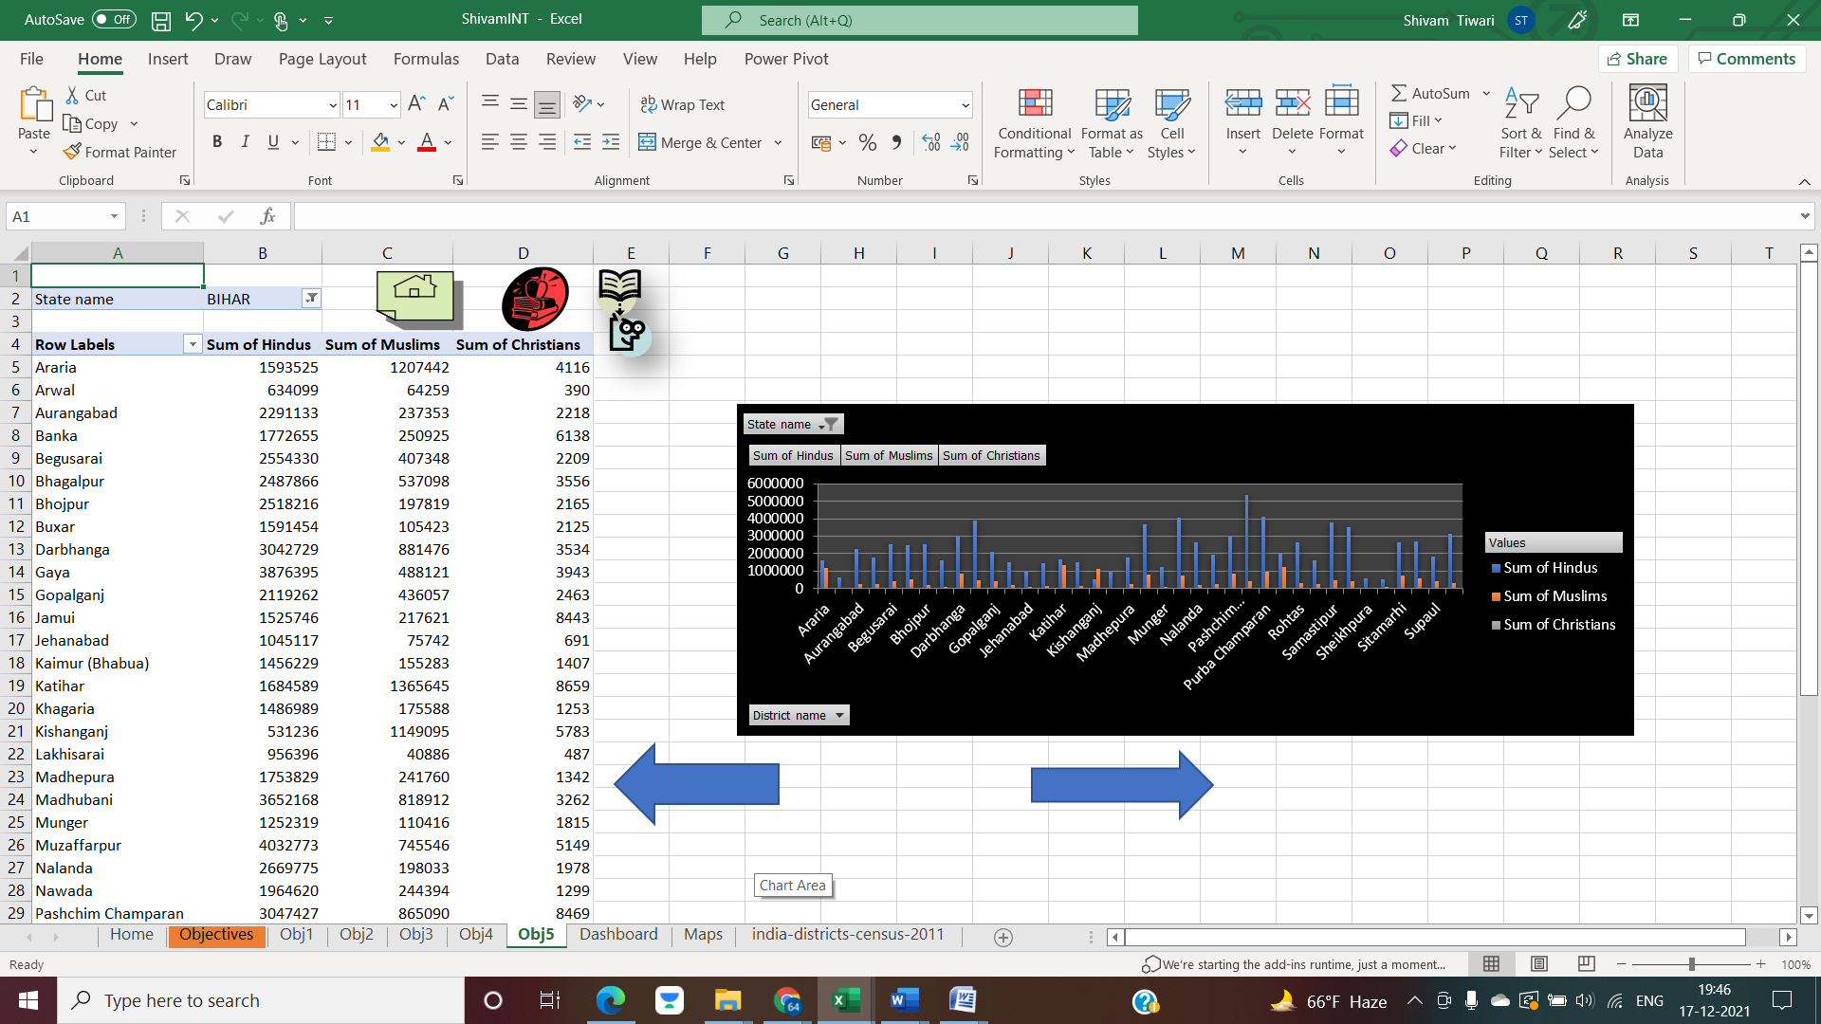

**Visualization**



**List of Analysis with Results**

* **Obj1**

**Analysis**

  
Top 5 districts in terms of population in Bihar are:

Patna

Purbi Champaran

Muzaffarpur

Madhubani

Gaya

Similar data can be abstracted for other states as well.

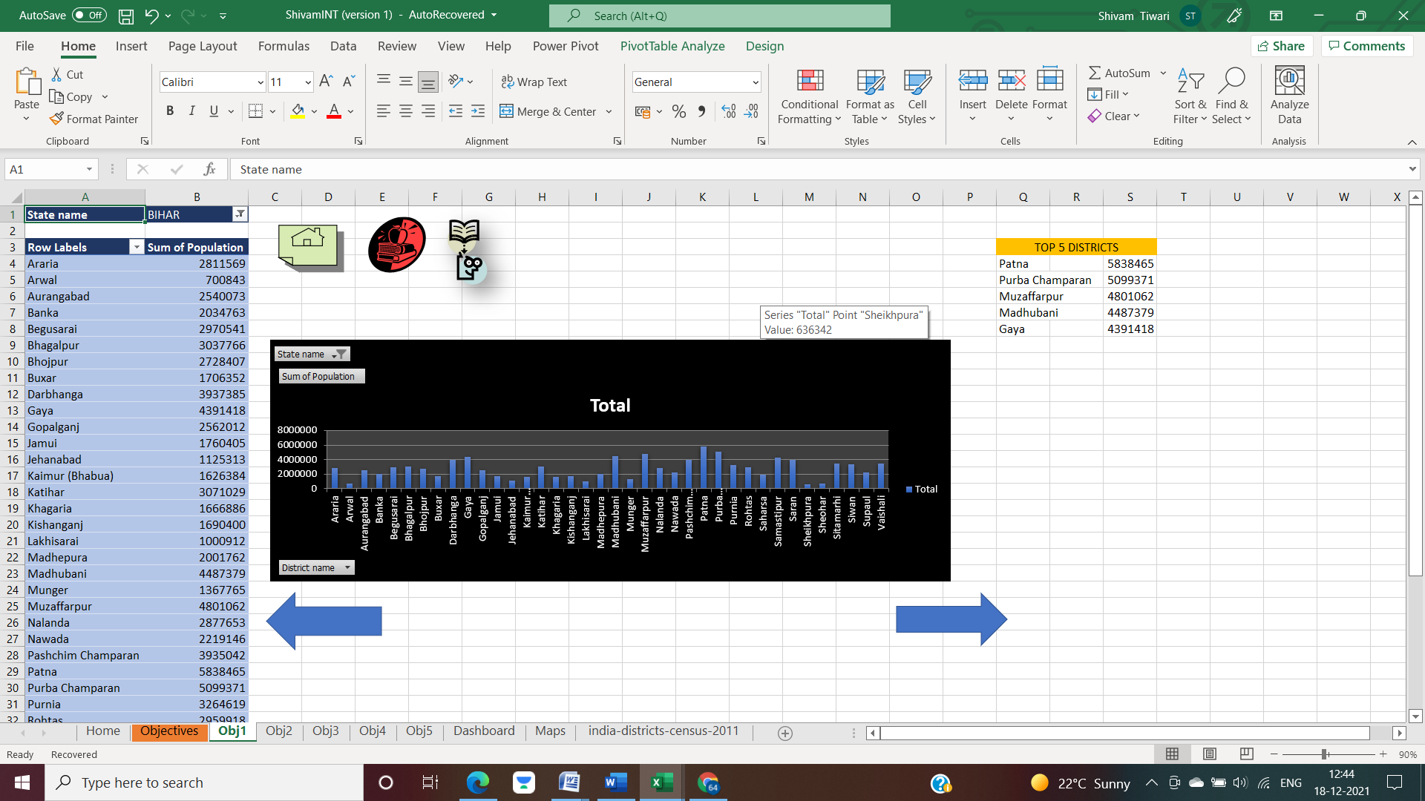

The map function chart below is showing the required data.

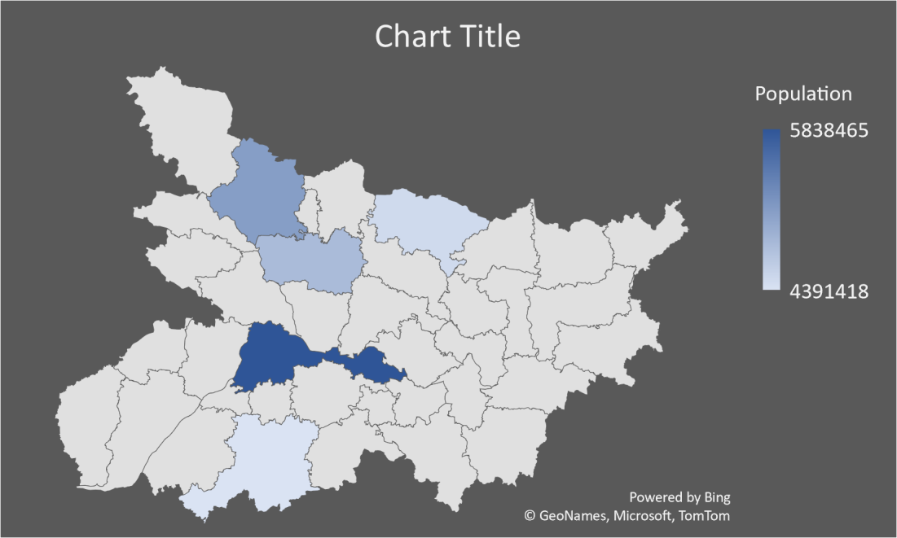

**OBJ2**

**Analysis**



The below chart best describes the analysis. Similar data can be obtained for other states as well.

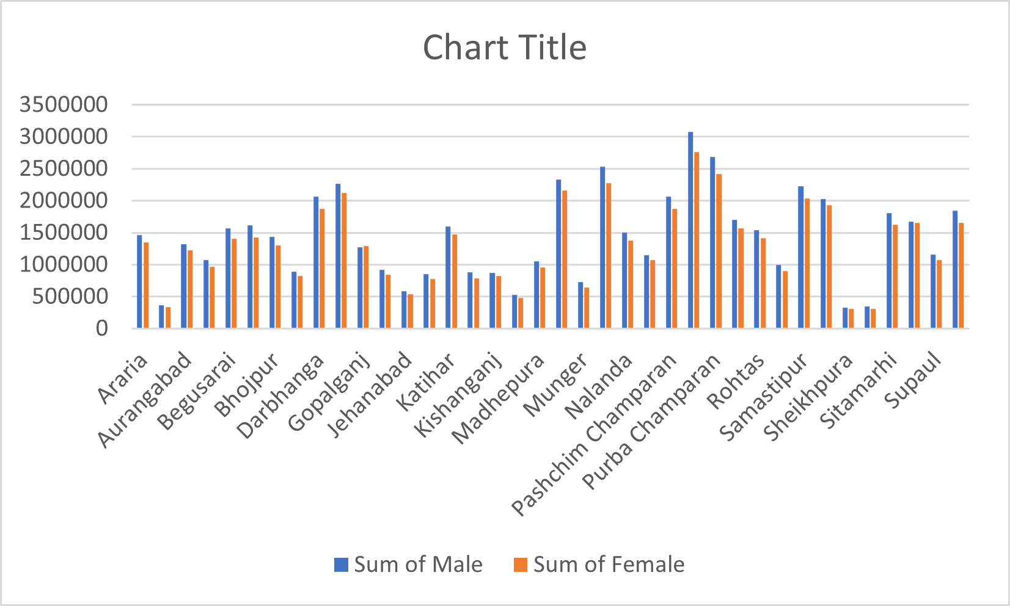

**OBJ3**

**Analysis**



The below chart best describes the analysis. Similar data can be obtained for other states as well.

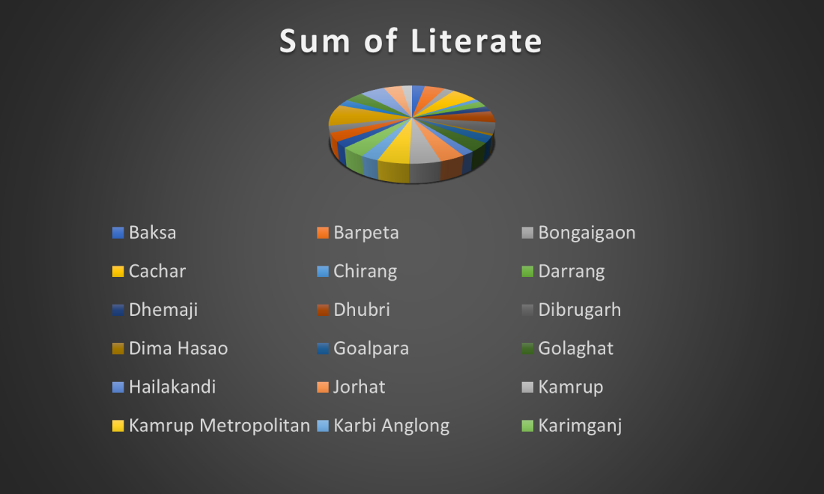

**OBJ4**

**Analysis**



The below chart best describes the analysis. Similar data can be obtained for other states as well.

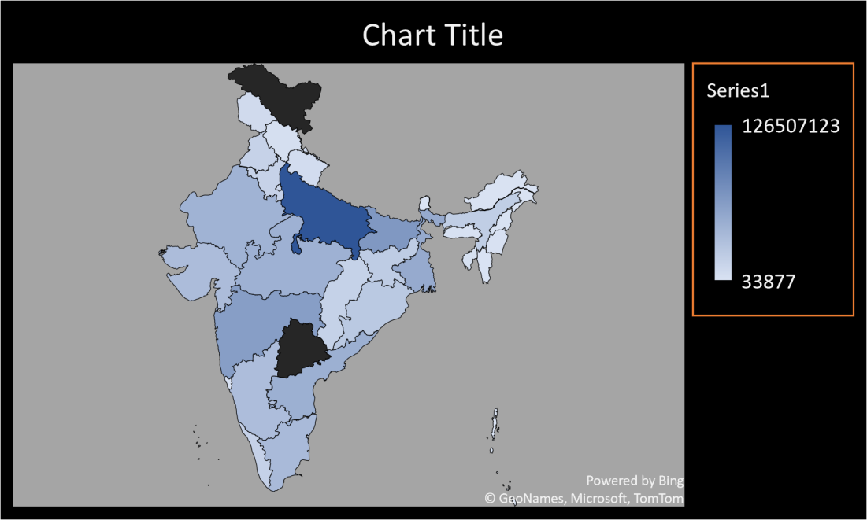

**OBJ5**

**Analysis**



The below chart best describes the analysis. Similar data can be obtained for other states as well.

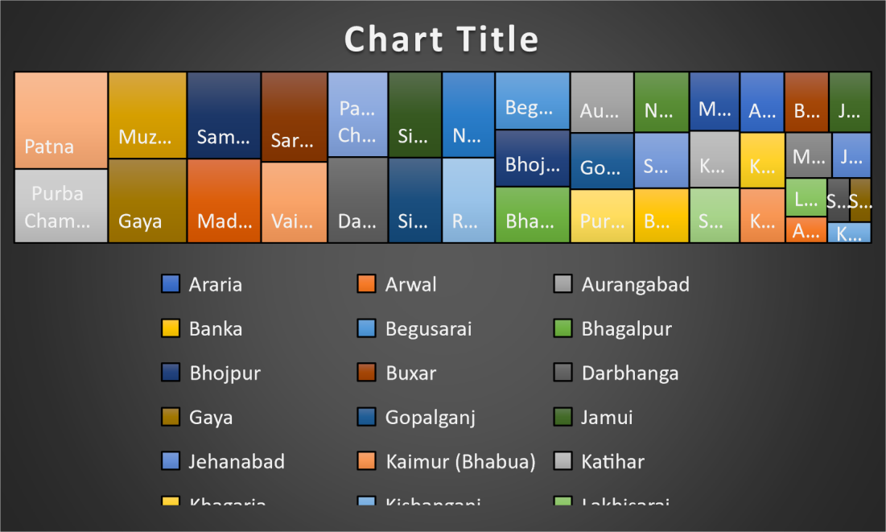

**Dashboard**

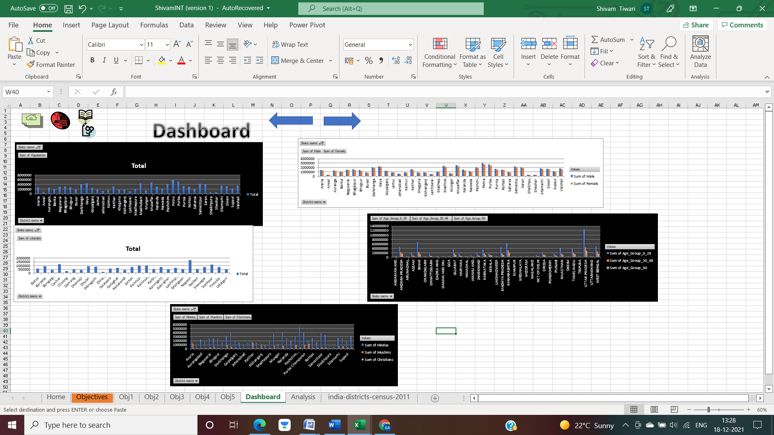

**Bibliography**

[www.kaggle.com/danofer/india-census?select=india-districts-census-2011.csv\](http://www.kaggle.com/danofer/india-census?select=india-districts-census-2011.csv\)[www.kaggle.com](http://www.kaggle.com)

<https://www.oracle.com/in/database/what-is-data-management/>

<https://www.guru99.com/etl-extract-load-process.html>

<https://www.geeksforgeeks.org/introduction-of-dbms-database-management-system-set-1/>

<https://support.microsoft.com/en-us/training>